Story Writing week 12
Use your imagination to write a story using the image below.
Girl and Dragon

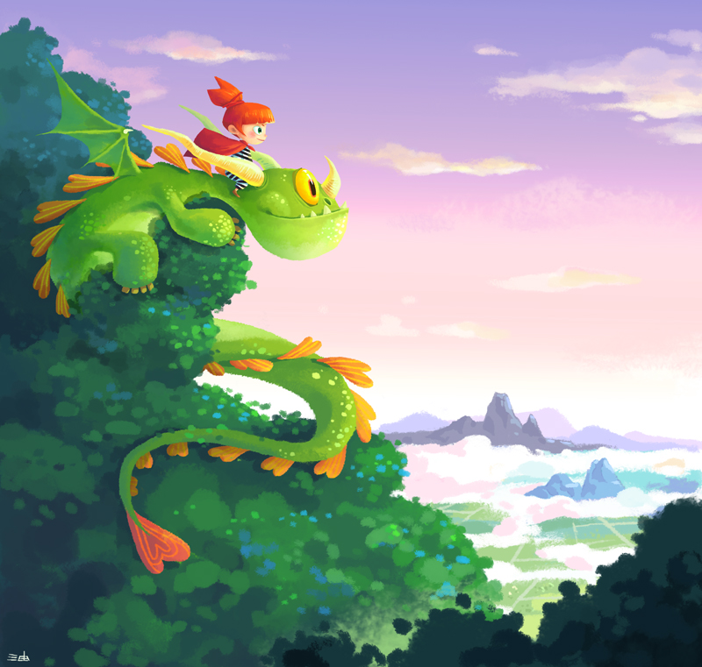

- Where are the girl and the dragon? What can they see from this place? What are they looking at?
- Why are they here?
- Are they friends? Does the girl own the dragon as a pet? Or does the dragon own the girl as its pet?
- What species of dragon do you think it is? Is it friendly?
- Does anyone else know that they’re up here? What might other people say about their friendship?
- Give this picture a new title. Explain your choices and persuade others that yours is the best title.
- Write about the adventures of the girl and the dragon.
- Grammar link: prepositions

