Useful apps for learning
App logo | App Name | Good for
 | TinyTap | Phonics  Maths
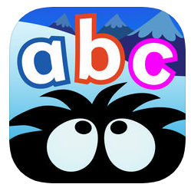 | Hairy Letters | Phonics
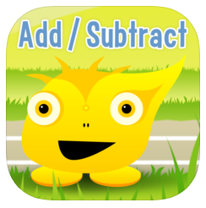 | Squeebles Addition & Subtraction | Maths-calculation
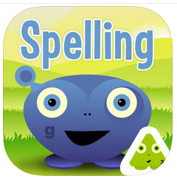 | Squeebles spelling test | Spelling phonics words or ‘tricky’ words
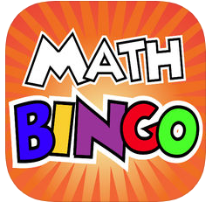 | Math BINGO | Maths-calculation
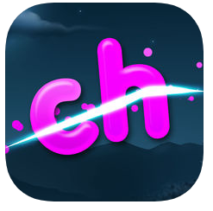 | Phonics Ninja | Reading sounds and words
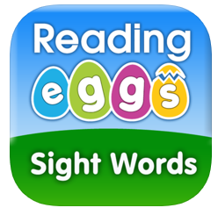 | Eggy 100 | Reading the first 100 sight ‘tricky’ words
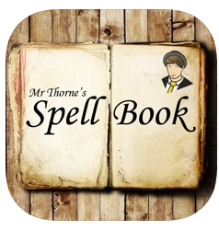 | Mr Thorne’s spellbook | Spelling phonics words or ‘tricky’ words

