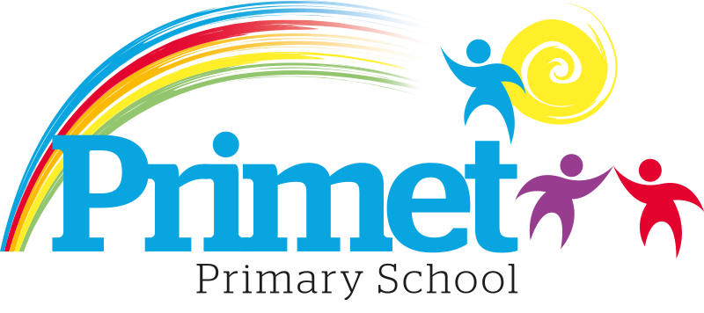
Pupil Premium Strategy statement 2021/2022

CONTEXT OF THE SCHOOL

The school is a average-sized Primary School with 195 (September 2021) pupils on roll.

Key features of the school

- 7 classes one form entry primary school.
- Socio-economic Taken from the 18/19 LSIP, Over deprivation index (A least E most deprived)
Education skills and training = E
Income = E
Employment = E
Health and Disability = E
Housing = A - because of close-proximity to public services
Crime = E
Living Environment = E
- Ethnic heritage, we have 12 different heritages at school;44% white/British, 27% Pakistani, Other white 10%, White and Asian 4%, other Asian 2% and Roma 3%
- Gender balance 49.7% Female 50.3% Male
- FSM 30% & 34% eligible for Pupil Premium funding. (EYFS PPG children to be included later once known)
- SEND 15%, 3 with EHCP 27 with SEN support. Likely to rise once EYFS included.
- CLA 0 families, 8 CAF’s
- Attendance:
Attendance including CME is 95.53% 2020/2021 +0.97% improvement (September 2019 to March 2020 was 94.56%)
Attendance excluding CME is 96.34% 2020/2021, this is closing the gap with National Average.

- Mobility:
The following KS1 children were not in reception in this school at the end of that year:
Y1: 1 children: (4%)
Y2: 10 children: (33%)

The following KS2 children were not in Y2 in this school at the end of that year:
Y3: 0 child: (0%)
Y4: 4 children: (13%)
Y5: 9 children: (41%)
Y6: 9 children: (27%)

Key information

Pupil summary | 2019/2020 |  | 2020/2021 |  | 2021/2022
Number of Eligible pupils | 71 | 33% High | 62 | 38% High | 63 | 31%  High
 |  | £85,540 |  | £76,950 |  | £88,355

Cohort information for 2021/2022

 | PPG Pupils | PPG Boys | PPG Girls | PPG SEND | NOR | PPG %
EYFS | 7 | 5 | 2 | ? | 27 | 26%
Y1 | 5 | 4 | 1 | 1 | 24 | 20%
Y2 | 10 | 5 | 5 | 1 | 30 | 33%
Y3 | 14 | 7 | 7 | 1 | 30 | 43%
Y4 | 12 | 5 | 7 | 3 | 30 | 40%
Y5 | 7 | 3 | 3 | 3 | 22 | 32%
Y6 | 9 | 4 | 5 | 3 | 33 | 27%
Total | 62 | 29 | 33 | 10 | 165 | 38%

Record of PPG Spending 2021/2022 Impact Report

Priorities for the spending for Pupil Premium children within the school is to close the learning gap for all disadvantaged children who access Pupil Premium funding. This spending has been directed towards improving attainment in Reading, Writing and Maths which links into our SIP 2021/2022.

Item/Project | Cost | Objective | Impact
Additional L3 TA to assist teaching of literacy and maths | £15,288 | To provide focused literacy and numeracy sessions to help progress of PP children. | End of key stage scores has closed the attainment gap. Pupil Premium children do better than non-pupil premium children in end of year testing.
1:1 tuition or small group work for pupils in Y2/Y6 reading recovery | £2,236 | To boost confidence and accelerate the progress of targeted individuals in English and Maths to increase the number of higher achievers at the end of Key Stage one and two. | The progress of pupils in year 2 and year 6 was increased resulting in improved End of Key Stage SATS results regardless of lost learning. Pupil premium children out performed children who are not pupil premium.  Year 6 Pupil premium out performed non-Pupil premium by +15%.
1:1 tuition or small group work for pupils in Y1 reading recovery | £2,589 | To boost confidence and accelerate the progress of targeted individuals in Reading | Improved outcomes for the Year 1 phonics testing with improved outcomes of 69%. +8% on the 2019 data.
Intervention Groups within all classes including Acquisition in English x1 HLTA, Phonics and other oral interventions  X5 TA’s L2/3 for working in the mornings. | £10,485  £41,197 | To boost confidence of children who are not yet proficient in English.  To deepen the knowledge and understanding of targeted pupils in Maths and English.  To improve the language and communication skills of targeted pupils.  . | Early identification of communication and interaction difficulties has proved beneficial to offer intervention to ensure Speech and Language does not limit or hinder learning. As a result, attainment in Reading and Writing has improved.  Targeted extra intervention in Early reading for Year 1 and Year 2 in 2021/2022. This has supported pupil premium children and the End of key stage scores has closed the attainment gap. Pupil Premium children do better than non-pupil premium children in end of year testing.
Intervention Well being Group  Training for new ELSA cover | ELSA £3614 for 3 afternoons  full year  £645 | To boost confidence and accelerate the progress of targeted individuals in reading and writing.  To increase self-esteem, independence and confidence of targeted pupils. | Interventions offered to targeted children across the school which accelerated the progress of pupil premium children through tailored interventions and support to fill gaps in learning as they were  Pupils with identified social, emotional or health needs receive weekly support to alleviate barriers to learning resulting in improved self-organisation skills, resilience and determination which allows them to work independently with confidence.  This has seen improved outcomes in all areas across the school with more children reaching the higher standard and age related expecattions at the end of the year assessments.

Access to breakfast | £100 for one week  May 2020 | To ensure Y2 and Y6 pupil premium children have breakfast  during SATs week & are all in school  on time | Improved outcomes for all pupils and children with pupil premium outperforming children with non-pupil premium.  All PP children attended breakfast club and were on time for their tests. Children were relaxed and calm before tests. See below for progress and results.
Y5/Y6 – Hygiene pack including – shampoo, shower  gel,  toothpaste/brush, deodorant, flannel, drawstring bag (£6 each) | £250 | To ensure that PP children have good hygiene habits. Year 5 and Year 6. | All children in Year 5 and Year 6 received a kit which was used by most children daily. Hygiene habits improved after this.  Central school resource has been created so all children can access these items if required.
Educational visits – whole school (£20 per child)  Y6 PGL  Derbyshire Y4/5 SACHS | £ 4000  SACHS visit paid from a charity. | To give PP children across the school experiences and opportunities the same as their peers.  To ensure PP children get the opportunity to build confidence, self/esteem and resilience. | Children were subsidised on visits and for the year 6 trip in July 2022.  15 children were supported with the SACHS residential in October 2021.  All Y6 children had leavers hoodies bought for them at the end of the year.
Family support worker | £1000 | To assist SEND with admin jobs – eg home visits, paperwork for meetings, minutes of meetings, phone calls.  Expenses.  To support PP families when needed | FSW assisted SEND with paperwork and jobs as delegated. PP families fed back as feeling supported by the FSW and SENCO.  Children and their families receive specialist support in a timely manner.
Total spent: £81,406 plus Contingency £6,929 = £88,335

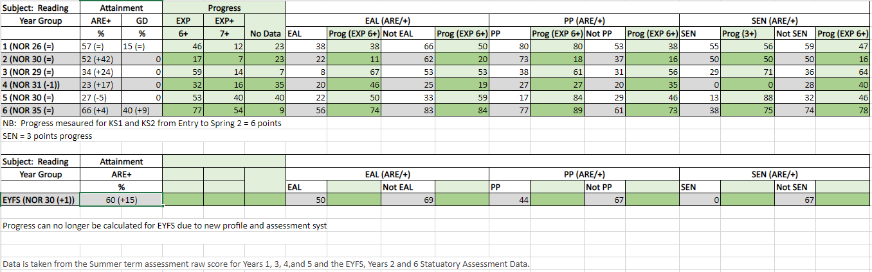
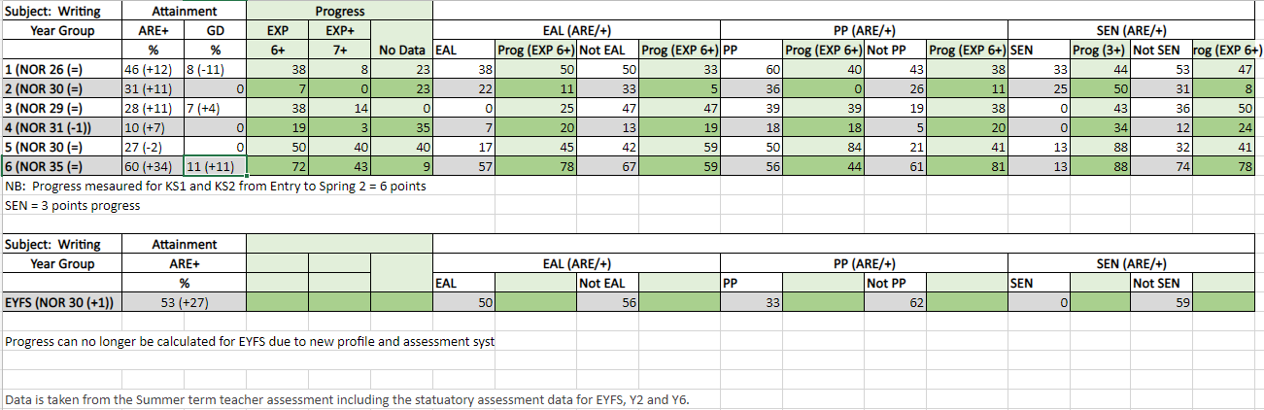
Written: September 2021
Reviewed June 2022

