Year 1 spellings
Week 7
Rule: The vowel diagraph ‘aw’ and ‘au’
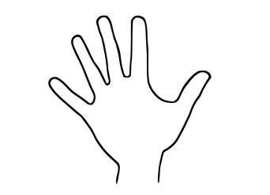
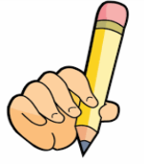
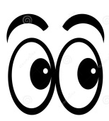
Look Say Cover Write Check

Spellings | 1st try | 2nd try | 3rd try
- saw
- draw
- yawn
- crawl
- claw
- author
- august
- dinosaur
- astronaut
- your

