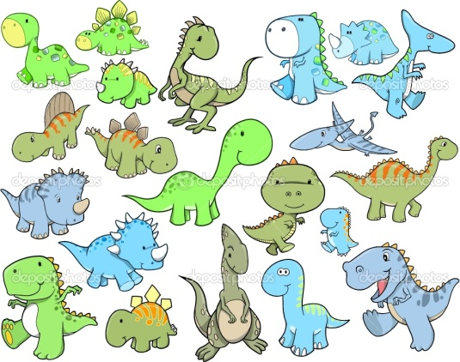
All about Dinosaurs

Long ago, before there were any humans, there were dinosaurs. Dinosaurs lived on the earth for over 165 million years but then they strangely became extinct, this means they all stopped living.
There were lots of different kinds of dinosaurs that lived at different times. Some were huge and some were much smaller. Some dinosaurs could move quite quickly on two legs. Others walked on four legs in a slow and clumsy way. Some dinosaurs could fly. The biggest complete dinosaur found by historians is the Brachiosaurus. It was about the length of two large school buses. The smallest dinosaur, the Compsognathus, was about one metre long and slightly bigger than a chicken.
Different dinosaurs liked to eat different things. Dinosaurs like the Diplodocus liked to eat leaves and plants: these types of dinosaurs are called herbivores. Some dinosaurs like the T-Rex liked to eat meat: these types of dinosaurs are called carnivores.

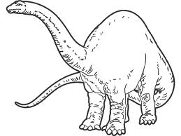
Check your work:
Write in full sentences with capital letters and full stops.
A full sentence includes some information from the question.
You can not start sentences with ‘and’ or ‘because’.

How long did the dinosaurs live on earth for?
_____________________________________________________
Did humans live on earth at the same time as dinosaurs?
_____________________________________________________
List the ways that the text says dinosaurs could move.
_____________________________________________________
How long was a Brachiosaurus?
_____________________________________________________
Name the animal that was slightly bigger than a chicken.
_____________________________________________________
What did the Diplodocus like to eat?
_____________________________________________________
What are dinosaurs that only eat leaves and plants called?
_____________________________________________________

