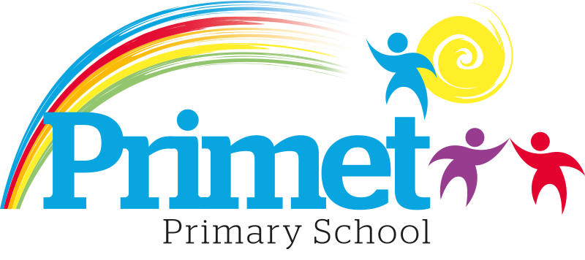
Catch up Funding Strategy statement 2021/2022

CONTEXT OF THE SCHOOL

The school is a average-sized Primary School with 195 (September 2021) pupils on roll.

Key features of the school

- 7 classes one form entry primary school.
- Socio-economic Taken from the 18/19 LSIP, Over deprivation index (A least E most deprived)
Education skills and training = E
Income = E
Employment = E
Health and Disability = E
Housing = A - because of close-proximity to public services
Crime = E
Living Environment = E
- Ethnic heritage, we have 12 different heritages at school;44% white/British, 27% Pakistani, Other white 10%, White and Asian 4%, other Asian 2% and Roma 3%
- Gender balance 49.7% Female 50.3% Male
- FSM 30% & 34% eligible for Pupil Premium funding. (EYFS PPG children to be included later once known)
- SEND 15%, 3 with EHCP 27 with SEN support. Likely to rise once EYFS included.
- CLA 0 families, 8 CAF’s
- Attendance:
Attendance including CME is 95.53% 2020/2021 +0.97% improvement (September 2019 to March 2020 was 94.56%)
Attendance excluding CME is 96.34% 2020/2021, this is closing the gap with National Average.

- Mobility:
The following KS1 children were not in reception in this school at the end of that year:
Y1: 1 children: (4%)
Y2: 10 children: (33%)

The following KS2 children were not in Y2 in this school at the end of that year:
Y3: 0 child: (0%)
Y4: 4 children: (13%)
Y5: 9 children: (41%)
Y6: 9 children: (27%)

Key information

Pupil summary | 2021/2022
195 pupils | Carry over from 2020/2021 £3,800  School led tutoring £8,100 + £2,700 from recovery funding £10,800  Recovery premium funding £7,160  Catch up funding £6,260  Total Funding £28,020

Cohort information for 2021/2022

 | PPG Pupils | PPG Boys | PPG Girls | PPG SEND | NOR | PPG %
EYFS | 7 | 5 | 2 | ? | 27 | 26%
Y1 | 5 | 4 | 1 | 1 | 24 | 20%
Y2 | 10 | 5 | 5 | 1 | 30 | 33%
Y3 | 14 | 7 | 7 | 1 | 30 | 43%
Y4 | 12 | 5 | 7 | 3 | 30 | 40%
Y5 | 7 | 3 | 3 | 3 | 22 | 32%
Y6 | 9 | 4 | 5 | 3 | 33 | 27%
Total | 63 | 30 | 33 | 10 | 166 | 38%

Record of Catch up Funding Spending 2021/2022 Impact Report

Priorities for the spending for Catch up funding children within the school is to close the learning gap for all children who the funding is targeted at funding. This spending has been directed towards improving attainment in Reading, Writing and Maths which links into our SIP 2021/2022.

Item/Project | Cost | Objective | Impact
1:3 tuition or small group work for pupils in Y2 and Y6. Autumn term  Targeted intervention with the children who are just below age expected goals in core subjects for the year. | X7 session at £20= £200  X13 groups =£1,820  Resources £2500 | Spring/Summer term.  To boost confidence and accelerate the progress of targeted individuals in English and Maths to increase the number of age-related expectations at the end of Key Stage one and two. Targeted year 2 and year 6 in the spring term. These children are targeted from Autumn assessments.  CGP bought for work with interventions across all year groups.  Children will be tracked on the outcomes at the spring and EOKS assessments. | See below for impact.
1:3 tuition or small group work for pupils in Y6, Y2 and Y5. Spring Term  Targeted intervention with the children who are just below age expected goals in core subjects for the year. | X10 session at £20= £200  X13 groups =£2,600 | Spring term  To boost confidence and accelerate the progress of targeted individuals in English and Maths to increase the number of age-related expectations at the end of year 5. Targeted year 1 and year 5 in the summer term.  Children will be tracked on the outcomes at the spring and EOKS assessments. | See below for impact.
TA supporting EYFS to improve social skills from loss of Early years support. | £5,050 | Support in EYFS, targeted children with specific needs. | See below for impact.
Improving phonics provision to impact on reading outcomes in KS1. | Books to support reading/phonics interventions.  £3750 | From Spring term ongoing.  To boost early reading in EYFS. Funding to access resources if required.  Measured with the number of children reaching ELG in reading and completing phase 3/4 in phonics. | See below for impact. Improved Phonics scores in KS1 achieving 69%. +8% improvement on the 2019 outcomes.
1:3 tuition or small group work for pupils in Y1 and Y5. Summer Term | X7 session at £20= £200  X10 groups =£1,300 | To be decided after the Spring assessment. | See below for impact.
Covering supply costs | £10,000 | To make sure that classes have continuity in teaching to maintain academic performance. | See below for impact.

Total spent: £27,050 plus Contingency £ 970= £28,020

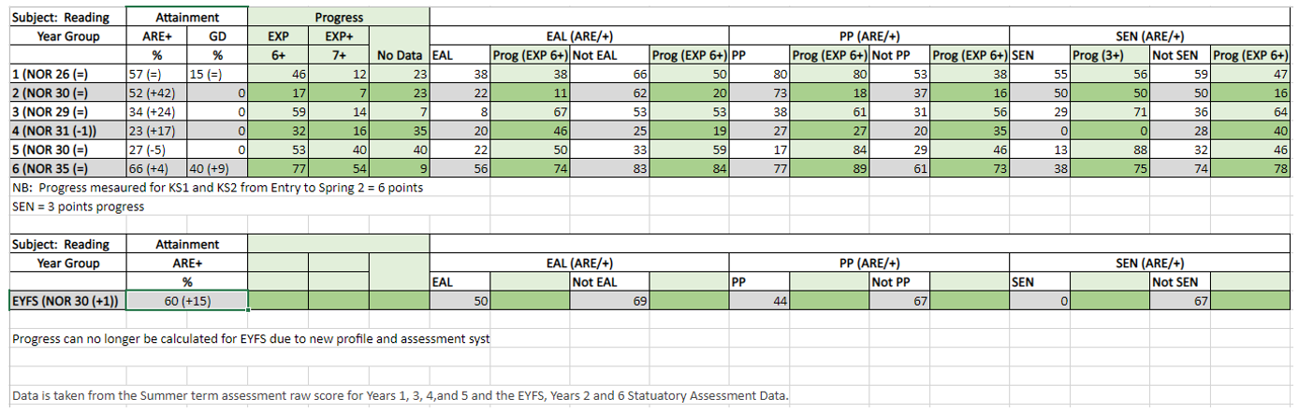
- Number for pupils achieving age related expectations have increased in all year groups except year 5. However, there have been 12 starters in this year group and out of the 12, 8 are new arrivals to the country with little or no English. Within the class, 6 children missed the pass mark for the reading test by 3 marks or less which would bring the percentage to 47% reaching ARE within the test. Without the 12 new starters and children working at expected or just below, the % achieving ARE would be 67%.
- Year 6 results improved from 10% 2019 data and 40% 2022 for reaching higher standard. +30% improvement.
- Year 6 reading has increased from 24% 2019 to 66% in 2022 +42% improvement.
- EOKS2 SS has increased from 94.8 2019 to 103.5 2022 +8.7
- Year 1 has performed really well and this has also been evidenced in the phonics score with 69% of children passing the phonics screening check. An improvement of 8% from 2019.
- Year 2 has seen the biggest increase in percentage compared to spring data.
- Year 4 is still a cohort that needs work with the lowest percentage of children reaching age related.
- Pupil premium pupils have outperformed non- pupil premium in all year groups except year 5.
- Best progress has been seen in years 6, 3 and 4.
- Most significant progress for EAL has been in years 3 and 4
- Progress for pupil premium better than non-pupil premium in years 1, 3, 5 and 6
- SEN children have expected or better progress in years 2, 3 and 5.

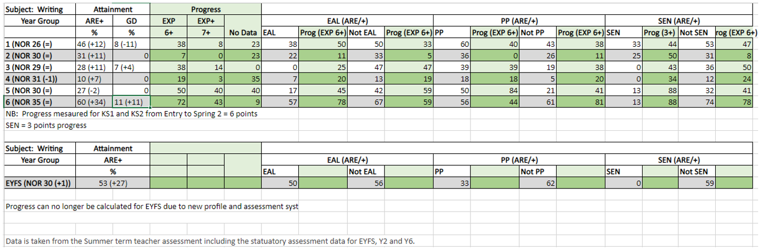

- Writing as a subject still under performs maths and reading respectively.
- Most increase in children reaching age related expectation is in year 6 and EYFS.
- All year groups are working under 65% of national expectations. This attainment gap has closed from 2019.
- Year 6 results in writing improved from 7% 2019 data and 11% 2022 reaching higher standard. +4% improvement
- Year 6 writing has increased from 55% 2019 to 60% in 2022 +5% improvement
- Year 6 results in GPS improved from 0% 2019 data and 23% 2022 reaching higher standard. +23% improvement
- Year 6 GPS has increased from 55% 2019 to 71% in 2022 +16% improvement.
- The SS in Year 6 in GPS has improved from 99 in 2019 to 103 in 2022 a 4-point improvement.
These results show that school is closing the attainment gap to national averages in Writing and GPS
- All year group have increased ARE except year 5 due to new arrivals. Without new arrivals 39% of pupils would have achieved age related expectation which is an increase of 10% from the Spring data. 66% of children are working at or just below.
- EAL children are performing lower than non-EAL due to their language development.
- Pupil premium children are outperforming non-Pupil Premium in all year groups except year 6.
- Most progress can be seen in years 6, 5, 3 and 1.
- 40% of class in year 5 not having data to compare which also accounts for the lower attainment.
- EAL children have made the most progress in Years 1 and 6. Progress for pupil premium is highest in Year 5 outperforming non-pupil premium and SEN have made better progress than non-SEN in all year groups except year 1 and 3. This may be a training need as these year groups have new staff members.

- 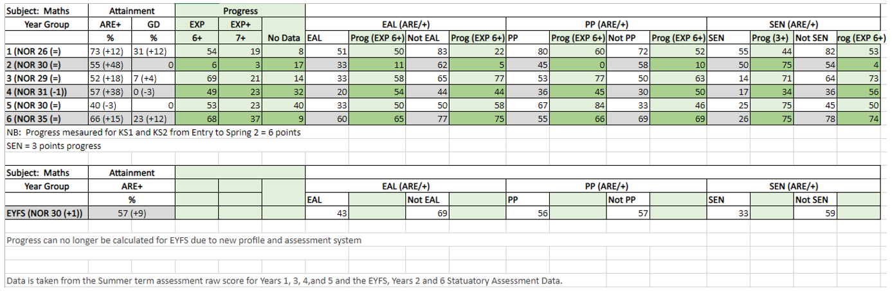
All year groups have seen an increase in the percentage of children achieving age related expectations except year 5 where there has been a 3% drop due to 12 new arrivals, 8 out which are EAL and new to country. Without the new arrivals, 56% of cohort would be at age related which would have been an increase of 56% compared to the spring data.
- Most notable increase has been in Year 2.
- Three-year groups have children working at greater depth with Year 1 having the biggest percentage of 31% and the Year 6 with 23%.
- Year 6 results in Maths improved from 0% 2019 data and 23% 2022 reaching higher standard. +23% improvement.

- Year 6 Maths has increased from 31% 2019 to 66% in 2022 +35% improvement.
- EOKS2 SS has increased from 96 2019 to 103 2022 an improvement of 7 points.
- Y4 multiplication scores show 2022 at +20 marks 66% +25 marks 23%
- More pupil premium are achieving age related expectation in years 1, 3, 4, and 5 than non-pupil premium.
- Progress within maths is good across the school except year 2. Other year groups have at least 50%+ of cohorts achieving 6 levels of progress or better. Within in year 2, there was however almost 50% increase in the number of children achieving age related expectation compared with spring data. This indicates that teacher assessment was not accurate at the end of year 1.
- EAL children have made better progress than non-EAL in years 1, 2 and 4.
- Pupil premium are making more or less the same progress or better than non-pupil premium across all year groups.
- SEN pupils have made better progress in years 2,5 and 6 than non-SEN.

- From the implementation of actions in this target, it has improved the EOKS outcomes in KS2 with the combines outcomes for the children. This improvement is from a clearer understanding of the expectations for teaching and learning and a more rigorous monitoring and training timetable for all staff. The impact of this has improved the provision of teaching and learning across the school for all staff. Combined outcomes have improved from 17% in 2019 to 57% in 2022 +40% improvement and children are now achieving the higher standard.
- Average scale scores for all subjects are now +100 for the first time and children are achieving the higher standard for the first time in all areas.

Written: September 2021
Reviewed: June 2022
Analysis of impact: September 2022

Autumn term 13 groups: Targeting Y2/Y6

 | Monday | Tuesday | Wednesday | Thursday | Friday
Wendi |  |  |  | Reading Year6 | GPS Year 6
Cat | Reading Year2 | Maths Year 6 |  | Maths Year 2
Amanda | Reading Year2 | Writing Year 2 |  | Reading Year6
Jodi | Maths Year6 | Maths Year6 | Maths Year2
Mel | Reading Year2 |  |  | Writing Year 2

Spring term 13 groups: Targeting Y2/Y5/Y6

Children to be identified after the November

 | Monday | Tuesday | Wednesday | Thursday | Friday
Wendi |  |  |  | Reading Year 6 | GPS Year 6
Cat | Reading Year 2 | Maths Year 6 |  | Maths Year 2
Amanda | Reading Year2 | Writing Year 2 |  | Reading Year6
Jodi | Maths Year 6 | Maths Year 6 | Maths Year 2
Mel | Reading Year 2 |  |  | Writing Year 2

