Year 1 spellings
Week 10
Rule: New consonant spelling ‘ph’ and ‘wh’
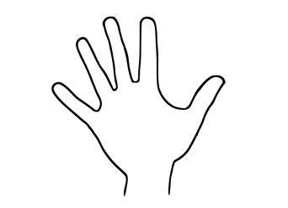
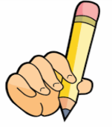
Look Say Cover Write Check

Spellings | 1st try | 2nd try | 3rd try
- dolphin
- alphabet
- phonics
- elephant
- when
- where
- which
- wheel
- white
- while

