MORNING SURPRISE
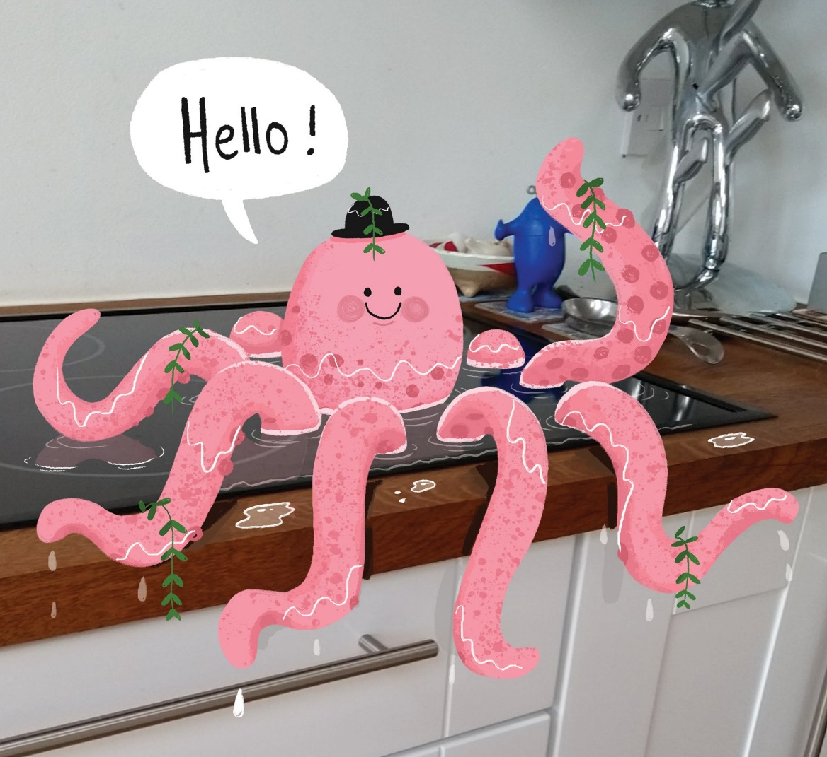
Write some sentences about this picture. Here are some tips.

Imagine that you have just walked into your kitchen to find this. Choose:
- Role play the conversation you might have with the octopus.
- Role play the telephone call you might have with a friend or family member to tell them what you have found.
- You can only ask 3 questions to the octopus. What would you ask and why?
- You decide to let the octopus stay here, but the next morning you come into your kitchen to find it joined by another creature. What might it be?
- The RSCPA rings and they are concerned: they have had reports from a neighbour that you are keeping sea life in your kitchen sink. What do you say?
- Try to persuade the octopus to leave. Then try to persuade it to stay. Which was easiest? Why?
- Write the story of how the octopus came to be here, and what happens next.
Questions:
- How did the octopus get here?
- Why is it wearing a hat?
- Is it speaking your language? Do you understand what it’s saying?
- Where did the plants come from?

