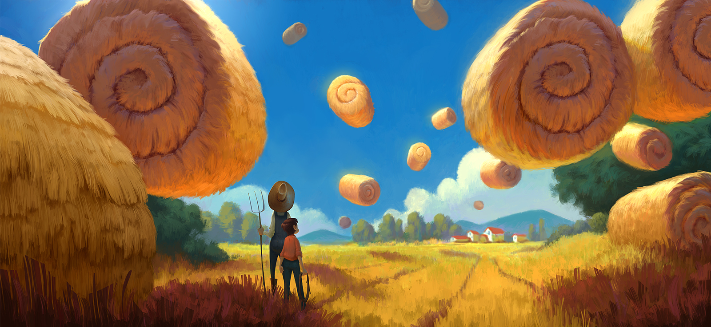
Grandpa's Farm
Write some sentences about this picture. Here are some tips.

- I can see …
- What is surprising about this picture?
- How are the hay bales floating?
- Are they still or moving?
- Who are the two people?
- What are they thinking?
- What are they going to do? Do they want to get the bales back onto the ground? Are they trying to get them all floating?
- What will happen next? Make a list of possibilities, then vote (most likely/most interesting/most unexpected).
- What would you do if you saw this?
- Drama: Be a news reporter, live at the scene. What will you say to the viewers? Follow this up with a newspaper report.

