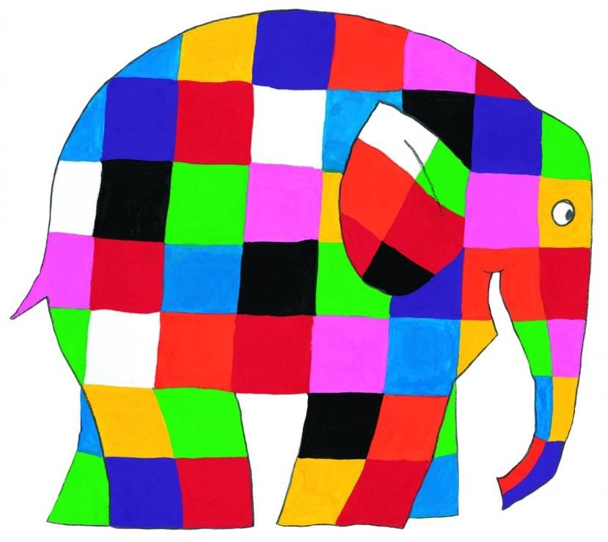

Year:

1

Term:

Autumn 1

202
2
/20
23

Tier 1 (Known Words) | Tier 2 (Sentence and Visual) | Tier 3
body, head, hand, arm, foot, leg, neck, face, shoulder, knee, fingers, toes, back, hair, eyes, nose, ears, mouth, skin, tongue, teeth & face | 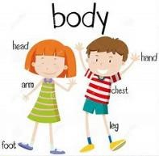  human body  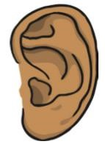  sense sight 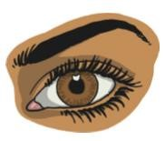 sound smell 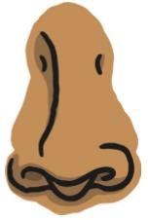touch 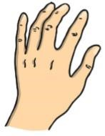taste 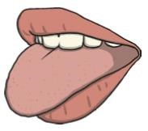  The five senses are sight, sound, smell, touch and taste. | Skeleton  The skeleton supports the body and protects softer body parts.  Muscles  Muscles move parts of the body.  Blood  Blood transports oxygen around the body.  Unique  Being unique means you are different to everyone else.

English (Objectives)  GPS:  Separate words with spaces.  Use punctuation to demarcate simple sentences (capital letters and full stops).  Use capital letter for the personal pronoun I.  Use capital letters for names of people, places and days of the week.  Identify and use question marks.  Identify and use exclamation marks.  Use the joining word and to link words and clauses.  Reading Comprehension  Recognise and join in with predictable phrases.  Become familiar with key stories, fairy stories and traditional tales.  Orally retell familiar stories.  Introduce and discuss key vocabulary, linking meanings of new words to those already known.  Activate prior knowledge e.g. what do you know about minibeasts?  Check that texts make sense while reading and self-correct. Explain clearly their understanding of what is read to them. Demonstrate understanding of texts by answering questions related to who, what, where, when, why, how Identify and discuss the main events in stories.  Identify and discuss the main characters in stories.  Discuss the title and how it relates to the events in the whole story.  Make basic inferences about what is being said and done.  Make predictions based on what has been read so far.  Participate in discussion and take turns.  Listen to what others say.  Writing (Objectives and Outcome):  Composition  Say out loud what they are going to write about.  Compose a sentence orally before writing it.  Write simple sentences that can be read by themselves and others.  Re-read sentences to check it makes sense.  Sequence sentences to form short narratives.  Discuss what they have written with the teacher or other pupils.  Read aloud their writing clearly to be heard by their peers and the teacher.  Handwriting  Sit correctly at a table holding a pencil correctly.  Form lower-case letters correctly – starting and finishing in the right place, going the right way around, correctly oriented. Form capital letters correctly.  Form digits 0-9 correctly.  Practice forming letters in handwriting families: -‘Long ladders’ – i, j, l, t, u, -‘One armed robots’ – b, h, m, n p, r -‘Curly caterpillars’ – c, a, d, e, g, o, q, f, s -Zig-zag letters – k, v, w, x, y, z  Spelling  Spell words using the 40+ phonemes already taught, including making phonically plausible attempts at more complex words.  Spell words with the sounds /f/, /l/, /s/, /z/ and /k/ spelt ff, ll, ss, zz and ck, e.g. off, well, miss, buzz, back. Spell words with n before k e.g. bank, think.  Divide words into syllables, e.g. pocket.  Spell words with -tch, e.g. catch, fetch, kitchen, notch, hutch.  Spell words with the /v/ sound at the end of words, e.g. have, live, give.  Add s and es to words, e.g. thanks, catches.  Add the endings –ing, –ed and –er to verbs where no change is needed to the root word.  Name the letters of the alphabet in order.  Use letter names to distinguish between alternative spellings of the same sound.  Write from memory simple sentences dictated by the teacher that include words using the GPCs and common exception words taught so far. | Maths (Red Rose Maths)  Number and Place Value  Measurement – Length and Mass  Addition and Subtraction  Geometry – 2D and 3D shapes | Art (Outcome and Objectives)  Draw and Paint - Picasso  Skills  Exploring and developing ideas  Drawing  Experiment with a variety of media; pencils, rubbers, crayons, pastels, charcoal, ballpoints, chalk.  Painting  Use a variety of tools and techniques including different brush sizes and types.  3D work  Experiment forms with using constructing and joining recycled, natural and manmade materials.  Explore sculpture with a range of malleable media.  Use simple 2-D shapes to create a 3-D form.  (Music – Unit)  Sing – Menu song and Hathi’s March  DT (Outcome and  Objectives)  Clay elephant  Evaluation of existing products Explore existing products and investigate how they have been made. Decide how existing products do/do not achieve their purpose.  Structures  Explore how to make structures stronger.  Design  Use pictures and words to convey what they want to design/make.  Propose more than one idea for their product.  Select appropriate technique explaining First… Next… Last….  Explore ideas by rearranging materials. Select pictures to help develop ideas. Use drawings to record ideas as they are developed.  Add notes to drawings to help explanations.  Describe their models and drawings of ideas and intentions.  Make  Discuss their work as it progresses. Select materials from a limited range that will meet the design criteria. Select and name the tools needed to work the materials.  Explain what they are making.  Explain which materials they are using and why.  Name the tools they are using.  Describe what they need to do next. Talk about their design as they develop and identify good and bad points. Note changes made during the making process as annotation to plans/ drawings.  Evaluation  Say what they like and do not like about items they have made and attempt to say why.  Discuss how closely their finished product meets their design criteria and how well it meets the needs of the user.
Science (Objectives)
Knowledge:
Observations of the local area
Seasonal changes
Observe changes across the four seasons
Observe and describe weather associated with
the seasons and how day length varies.
Skills:
Questioning
Asking simple questions and recognising that
they can be answered in different ways.
Planning
Performing simple tests.
Measuring
Observing closely, using simple equipment.
Recording
Gathering and recording data to help in answering
questions. identifying and classifying.
Concluding
Using their observations and ideas to suggest
answers to questions.

Humanities (Geography – Objectives)
What can we see around our school?
Skills
Knowledge
To understand changes within living memory. Where appropriate, these should be used to reveal aspects of change in national life.
Skills and fieldwork
Use simple fieldwork and observational skills to study the geography of their school and its grounds.
Use locational and directional to describe the location of features and routes. Devise a simple map.
Human and Physical Geography
Use basic geographical vocabulary to refer to key human features including: house, shop, town.

R.E (unit)
Christianity - God

ICT (Teach Computing)
Technology around us.

PSHE (Unit)
Families and friendships Roles of different people
P.E (Unit)
Gym and Games

Enrichment (Visits/Visitors/Parent Showcase)
Local area walk

