Story Writing week 7
Use your imagination to write a story using the image below.

PANDA POST
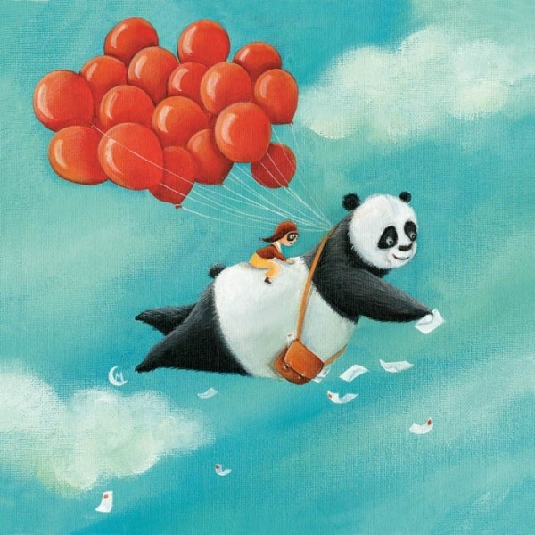

- What is happening here?
- How are the panda and the child managing to fly?
- Why is the panda dropping envelopes? What is inside?
- How does Panda Post work? Write an explanation of it.
- Tell the story of Panda Post only through a collection of letters delivered by the panda. What do the letters say? Who are they from? Will there be any links between them?

