Year 2 spellings-
Group 2
Week 4-‘ay’ phoneme
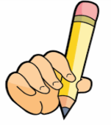
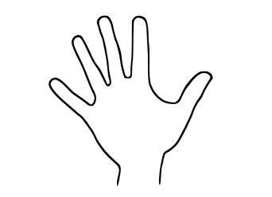
Look Say Cover Write Check

Spellings | 1st try | 2nd try | 3rd try
- May
- clay
- away
- play
- stay
- tray
- hay
- spray
- say
- pay

