Year 2 spellings
Group 2
Common exception words

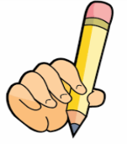
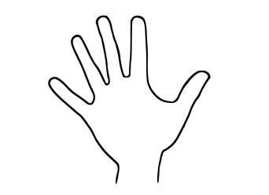
Look Say Cover Write Check

Spellings | 1st try | 2nd try | 3rd try
- they
- were
- said
- you
- your
- here
- there
- where
- come
- some

