Story Writing week 10
Use your imagination to write a story using the image below.
You’re going to need a bigger boat
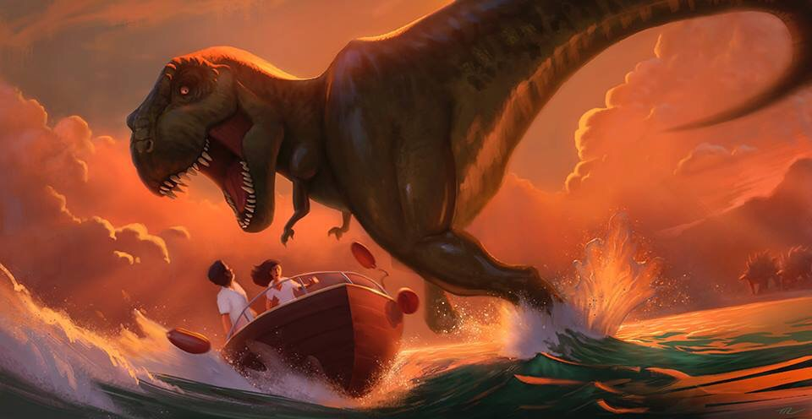

- Who are the people?
- Where is this?
- Where did the T-Rex come from?
- What are the characters thinking?
- What do you think will happen next?
- Tell this story

