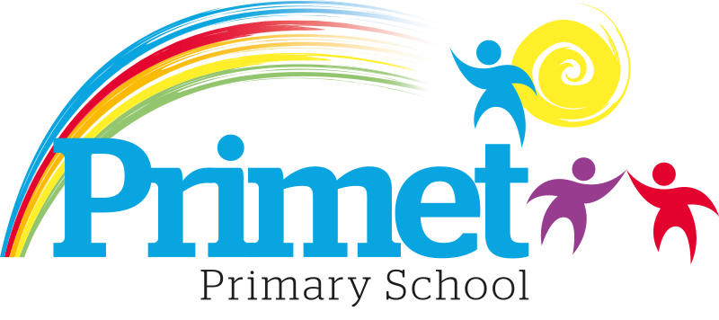

Primet Primary School Priorities for 2022/2023

Key Priority 4 | To improve the leadership and management at all levels.
Key Priority 3 | To improve the standards in EYFS by improving the quality of Teaching and Learning.
Key Priority 1 | To improve the quality of the teaching and learning in reading to increase the standards of attainment across all year groups.
Key Priority 2 | To improve the standards in Writing by following the non-negotiables and the teaching of writing across the school and generating excellent teaching of GPS, reading and spelling through writing.

