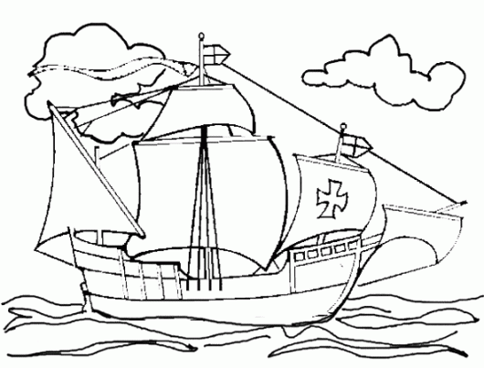
sails mast deck crow's nest rigging sailors bow stern

