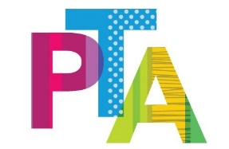
Easter
Competition

Following the success of last year’s Easter competition, the PTA have decided to run another competition but this time we want you to design an Easter hat or Bonnet. Each entry must be created by you.
Please send photos in to school of your entry (email to Admin@primet.lancs.sch.uk) Entries must be received by Tuesday 21st April. The winners will be announced on Friday 24th April as part of our virtual assembly that day. There will be a prize or EYFS and KS 1, a prize for KS2 and a prize for parent or carer.
You can either draw your design for the bonnet or you can actually make one if you have a cap or hat at home that you could decorate.
Don’t forget to send you photos in. Please put PTA competition entry in the title of your email.
Good Luck Everybody!






