
WELCOME TO RECEPTION

Dear Parents/ Carers
My name is Mrs Bury and I am very excited to be your child’s teacher in September. We will soon be arranging some ‘stay and play’ sessions where you and your child can meet the staff and explore our large classroom area. In the meantime, here is some key information that help to answer any questions you may have. ​​​

Lunches and snacks
For Reception and Key Stage 1, lunches are free and there are lots of hot and cold options. However, children can bring their own packed lunches if they prefer. Children are also provided with a fruit snack in the morning and fresh water is available throughout the day for children to drink.
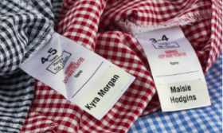
Labels
Please ensure all your child’s clothing, coat, bag and water bottle are labelled as it makes it easier to find missing items. Please send your child with spare underwear and socks as accidents do happen – especially in September.

School Times
School registration is between 8.35-8.45am. A gentle reminder that Arriving 5 minutes late to school every day adds up to roughly 3 days lost over the course of one year. We finish school at 3.15pm.

Before and After School Club
Our school offers before and after school club care every day during term time. Morning sessions include breakfast and run from 7.15am-8.45am. Afternoon sessions run from 3.15pm to 5.10pm. Please see the school office regarding costings and for a place.

Absence
If your child is going to be absent from school, please ring the school office by 9.30am. Any absence not verified by a parent has to be entered in our register as an unauthorised absence. We will contact you if your child is not in school by 9.30am and we have not heard from you.

Attendance
We place great emphasis on good attendance at school. Days missed is learning lost. Please endeavour to arrange appointments at doctors and dentists after school hours. Sometimes it is unavoidable especially in cases of hospital appointments.

Communication
If you have any concerns or questions, I am available any day after school. We have a parent’s information board in the entrance hallway, which is updated regularly with different information. This information is also emailed and texted out through our school messaging service.
In the entrance hallway, we have a learning journey wall and book with updates about what your child has been learning each week, this information will also be available on the school website. We also use Tapestry, which is an online platform, allowing us to send you updates and photos of your child’s learning.
Phonics and reading books
In EYFS we learn to read through the use of phonics. We learn each letters individual sound and build these together to decode a word. Your child will soon be given a school reading book starting with wordless books. It’s important that you read with your child as often as possible to give them the best start in life. Here are some activities and ideas for sharing these books with your child:
- Look at the front cover, ask your child what they think the book is about?
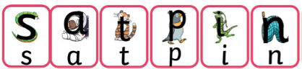
- Ask them to describe what they see in the pictures.
- Ask your child to find items in the book.
- After reading, ask your child to retell the story. Did they enjoy it?
Record any comments in your child’s reading record book, every time you read together.

Am I Ready for School?
When your child starts school there are a number of skills that they should ideally have mastered. Use this sheet as a guide to help track their progress.
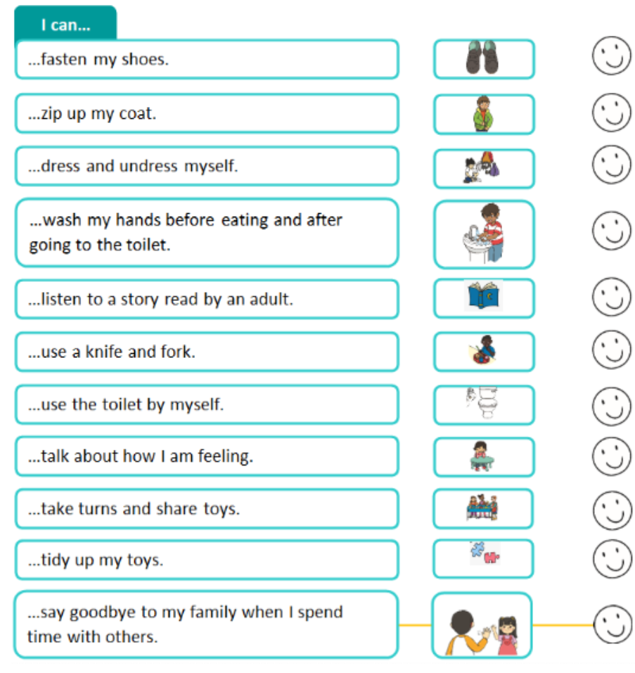
Class Dojo
We use an online platform called Class Dojo to celebrate your child’s achievements at school. We will invite you to join when your child starts school and you can access this either online or by downloading the app.
What next?

We will be contacting you shortly to arrange home visits. Where your child can meet the class teach in a setting that is comfortable to them. We will then arrange ‘stay and play’ sessions, where your child can visit school to get used to the setting.
If you require any further information, please feel free to contact us on:
Phone: 01282 864607
Or email the school office at: sbm@primet.lancs.sch.uk
See you soon

