YEAR 1 | Autumn 1 | Autumn 2 | Spring 1 | Spring 2 | Summer 1 | Summer 2
Theme | This is me | Festivals and Celebrations | Kings, Queens and Castles |  | Step in the Wild | United Kingdom
English Text/ Film and linked texts | 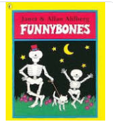  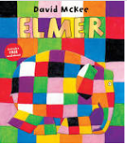  Elmer by David McKee  Funny Bones by Ahlberg | 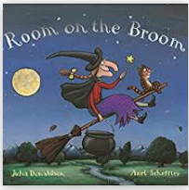  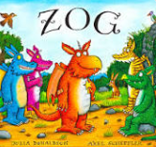  Room on the Broom by Julia Donaldson  Zog by Julia Donaldson | 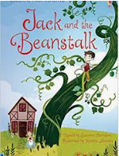  Jack and the Beanstalk by Susanna Davidson | 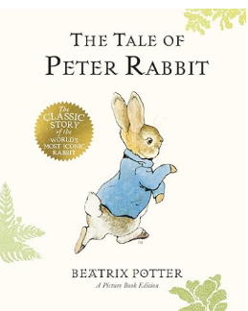  The Tale of Peter rabbit by Beatrix Potter  The Complete Adventures of Peter Rabbit by Beatrix Potter | 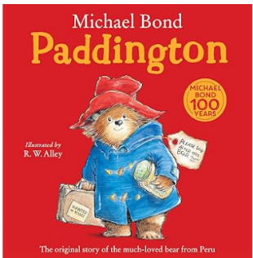  Padding Bear by Michael Bond  Paddington at the Zoo by Michael Bond | 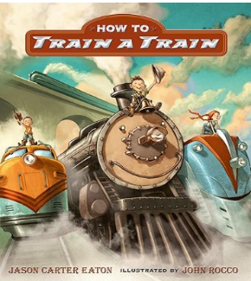  How to Train a Train by Jason Carter Eaton  Thomas and Friends Thomas Goes Crash! By Egmont Publishing UK  Wanted: The Perfect Pet by Fiona Roberton  The Perfect Pet by Margie Palatini  My Pet Star by Corrinne Averiss  National Geographic Look & Learn – Dogs
Main Writing Outcome 1  Text  Audience  Purpose  Structure and Skills  Additional outcomes | T: Description about myself /animal  A: school library  P: to inform  S: a short paragraph  S: capital letters, pronoun I, simple sentences, concept of a sentence, finger spaces  AO: labelling the body | T: Stories with repeating patterns  A: Julia Donaldson  P: to entertain  S: beginning, middle, end  S: capital letters, full stops, joining word ‘and’ to link words and clauses, capital letters for names, | T: Setting description  A: display  P: to entertain  S: where, when, senses, weather  S: capital letters, joining words ‘and’ and ‘but’, questions marks  AO: missing poster, instructions of how to plant a bean | T: Recount in role of Peter rabbit/ Benjamin Bunny  A: Beatrix Potter  P: to express  S: events and feelings in chronological order  S: pronoun I, question marks, joining words ‘and’ and ‘but’ to join clauses  AO: character profile, role of the wall | T: Story in a similar style  A: Class anthology  P: to entertain  S: beginning, middle, end  S: capital letters, sentences with joinign words and and but, excalmation marks  AO: setting description | T: A guide for looking after pets  A: Vets for pets, Colne  P: to inform and explain  S: what is looks like, what it eats, what it likes to do  S: joining words and but or, words ending er est, exclamation marks  AO: top trumps car  description of a train
Writing Outcome 2  Text  Audience  Purpose  Structure and Skills  Additional outcomes | T: Information poster about elephants/ another animal  A: National Geographic Kids Magazine  P: to inform and explain  S: title, image, description  S: capital letters, full stops, questions marks, simple sentences, finger spaces  AO: descriptive sentences, questions | T: Instructions of how to trap a dragon/ different animal  A: class collection for the class library  P: to instruct  S: title, what you need, steps  S: capital letters, full stops, words ending ‘ed’  AO: letter to the dragon, letter to Santa |  | T: Innovated story  A: Colne Library  P: to entertain  S: beginning, middle, end  S: capital letters for names, joining words ‘and’ and ‘but’ to join clauses  AO: dictated sentences | T: Animal fact file  A: Eco Kids Magazine  P: to inform  S: title, what is looks like, where it live, what it eats  S: CL for names, sentences that make sense, full stops, prefixes ‘un’ | T: Story book based on an episode  A: BBC  P: to entertain  S: beginning, middle, end  S: Sentences with capital letters and full stops, capital letters for names, exclamation marks  AO: sentences based on songs

