Our Island Home

Year: 1 Term: Spring 1

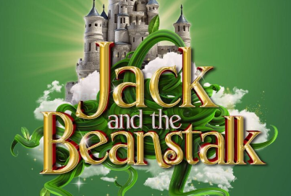

Tier 1  (Known Words) | Tier 2  (Sentence and Visual) | Tier 3
Map  World  Weather  Season  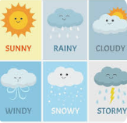  Rain  Sun  Cloud  Snow  wind  Hail | 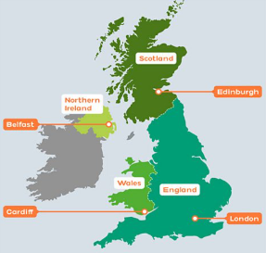  United Kingdom  Capital Cities  Scotland – Edinburgh  England – London  Wales -Cardiff  Northern Island - Belfast | 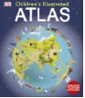  Atlas  A book of maps or charts.    Globe - A globe is a spherical model of Earth,

DT – Preparing food and Combining

Design
- Use pictures and words to convey what they want to design/make. Propose more than one idea for their product.
- Select appropriate technique explaining First… Next… Last….
Make
- Discuss their work as it progresses.
- Select materials from a limited range that will meet the design criteria. Select and name the tools needed to work the materials.
- Talk about their design as they develop and identify good and bad points. Note changes made during the making process as annotation to plans/ drawings.
Evaluation
Say what they like and do not like about items they have made and attempt to say why.
Discuss how closely their finished product meets their design criteria and how well it meets the needs of the user.

Health
PSHE (Unit)
Belonging to a community.

- What rules are.
- caring for others’ needs
- looking after the environment
P.E (Unit)
Athletics and Games –
- Catching and bouncing

ICT (Rising Stars Unit)
- Moving a Robot

Music - Sing

- ‘Football’ and ‘The sea’.

Enrichment (Visits/Visitors/Parent Showcase)
Fire service visit

English (Objectives)  GPS:  - Use capital letter for the personal pronoun I. Use capital letters for names of people, places and days of the week. Identify and use question marks. Identify and use exclamation marks.  - Extend range of joining words to link words and clauses using but and or.  - Add suffixes to verbs where no spelling change is needed to the root word e.g. helping, helped, helper.  - Add the prefix ‘ un’ to verbs and adjectives to change the meaning e.g. untie, unkind.  Reading Comprehension  - Listen to and discuss a range of poems, stories and non-fiction at a level beyond that at which they can read independently. Link what they have read to own experiences.  - Recognise and join in with predictable phrases.  - Enjoy and recite rhymes and poems by heart.  - Demonstrate understanding of texts by answering questions related to who, what, where, when, why and how.  - Discuss the title and how it relates to the events in the whole story.  - Make basic inferences about what is being said and done.  - Make predictions based on what has been read so far.  - Participate in discussion and take turns.  - Listen to what others say.  Writing (Objectives and Outcome):  Composition  - Say out loud what they are going to write about. Compose a sentence orally before writing it.  - Sequence sentences to form short narratives to describe or re-tell.  - Write Character descriptions  - Write a plant diary | Maths (Red Rose Maths Mastery)  Number and Place Value  Mass/Weight  2D and 3D shape  Counting and Money  Multiplication  Division
Science (Objectives) Animals

Identify name draw and label the basic parts of the human body and say which part is associated with each sense.
Recognise that humans are animals
Recognise that humans have many similarities.
-To identify and name a variety of common animals including fish, amphibians, reptiles, birds and mammals. -To identify and name a variety of common animals that are carnivores, herbivores and omnivores. - To describe and compare the structure of a variety of common animals (fish, amphibians, reptiles, birds and mammals, including pets)

Skills:

Questioning Asking simple questions and recognising that they can be answered in different ways.

Recording Gathering and recording data to help in answering questions. identifying and classifying.
Concluding classifying animals
Humanities (Geography– Objectives)
What do we know about our Island home.
Name, locate and identify characteristics of the four countries and capital cities of the United Kingdom.

R.E (unit)
Islam
Where is God? Talk about Allah, creation and Living things.

Using their observations and ideas to suggest answers to questions.
words taught so far.
Switched On – Online Safety We are storytellers

