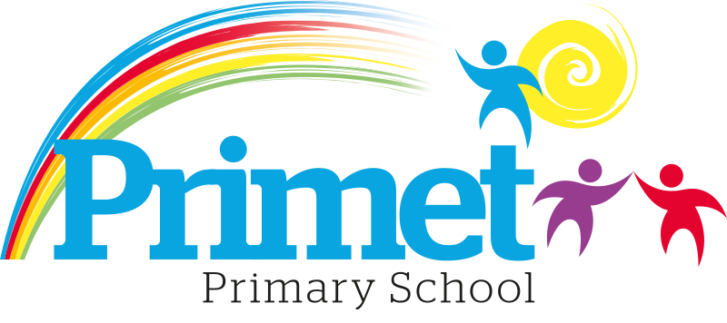

Reading Policy

Intent

At Primet Primary, our intention is to deliver a creative Reading curriculum with enriching reading opportunities, which will inspire and enthuse children to develop a life log love for reading. Children will be provided with opportunities orally to practice and reinforce their learning through active learning styles. Through the Reading curriculum, we will enable children to read and learn ambitious vocabulary; become confident with different genres of books; and apply their reading knowledge to their writing. We intend to provide opportunities to consolidate and reinforce taught reading skills across the curriculum, where children can confidently and creatively apply their learning.

Aims and Principles

At Primet Primary school we strive for children to be a ‘Primary Literate Pupil’. We aim for a child to be able to:

- Read a range of texts fluently for pleasure, information and with comprehension
- Develop lifelong enjoyment and pleasure in reading
- Understand a range of text types and genres
- Be curious learners – visiting the past, future, and other worlds – imaginary and real!

Non-Negotiables Procedures and Practice

- Statutory requirements for the teaching and learning of English are laid out in the National Curriculum English Document(2014) and in the Statutory Framework for the Early Years Foundation Stage (2021).
- EYFS and KS1 children will follow the Little Wandle scheme, which is related to children’s phonics phases. These consist of a practice read, prosody and comprehension. In addition, children will have a weekly comprehension lesson and the opportunity to read a book for pleasure.
- KS2 have a reading session everyday which focuses on a whole class teaching approach. The sessions consist of reading the statutory words, two reading skill lessons, comprehension and a reading for pleasure session.
- Children take home a reading book based on their reading/phonics stage and a book of their choice. Each child will have a ‘home reading book’ in which any reading at home is noted. Daily reading at home is encouraged.
- In English lessons, shared reading is integral aspect and occurs within the reading phase.
- To ensure there is a daily 1:1 reading session for the lowest 20% of pupils in each class.
Oracy

- Spoken language underpins the development of reading and writing. In line with the National Curriculum, pupils are taught to speak clearly, express their ideas, and listen and respond appropriately to others.
- Teachers use structured discussion, storytelling, drama, debate, and guided reading so children learn to articulate their thoughts, deepen comprehension, and develop vocabulary.
- Oracy is embedded in all reading sessions, enabling pupils to rehearse language, clarify meaning, and develop confidence in verbal expression. For example, pupils may discuss a character’s motivations in a shared text, perform a poem aloud, or engage in a ‘Book Talk’ session where they justify their opinions with evidence from the text.

Fluency

- Fluency is the bridge between word recognition and comprehension. The National Curriculum highlights that pupils should read ‘accurately, fluently and with understanding.’
- Fluency is taught through regular modelled reading, echo and choral reading, paired reading, and repeated reading of familiar texts. Pupils are encouraged to read with appropriate pace, expression, and phrasing, supporting their ability to make meaning from text.
- Teachers will assess fluency not only by speed and accuracy but also through prosody: how well pupils use intonation and rhythm to convey understanding.

Cross-curricular Reading

- Teachers will make cross curricular links where children can apply skills they have learnt in whole class reading and in English. Opportunities to apply cross curricular reading skills are outlined on the English Overview.
- Children will be given an opportunity to attend the school library to select cross curricular books related to their topic every half term or every new topic.

Assessment

- Reading will be assessed as entering, developing, secure or greater depth based on their age-related expectations and the data entered and tracked using INSIGHT tracking system. This is based on both teacher assessment and a ten weekly reading assessment.
- Data from assessments will be used to identify gaps that will inform planning lessons and identify pupils who need reading interventions.
- End of year assessments will inform action planning and CPD training programme.
- The Foundation Stage Profile is used to assess the early learning goals for literacy and communication and language development.

Statutory Assessment

Year 1 children are assessed against the Government’s Standardised Phonics Assessment in the summer term.
Year 6 children are assessed using the Government’s standardised Reading Test [SATs].

Data from all assessments is shared with senior leaders in Pupil Progress meetings termly.
Next steps decisions are considered and intervention strategies are put into place to address any underachievement.

Roles and Responsibilities

The subject leader is responsible for improving the standards of teaching in Reading through:
- Pupil progress
- Provision of reading (including intervention and support programmes)
- The quality of the learning environment/reading areas
- Auditing and supporting colleagues in their CPD
- Purchasing and organising resources
- Keeping up to date with recent developments/changes

Monitoring and Evaluation

- Whole Class Reading lessons will be monitored through informal learning walks and formal observations to ensure high quality teaching and learning is taking place.
- Team teaching and a lesson study approach will allow good teaching practices to be developed through peer planning and evaluation.
- Books will also be scrutinised in order to monitor children’s learning and assessment both though leadership as well as a peer approach.
- Pupil interviews will also be conducted in order to gain a child’s perspective of their English learning.

Updated 10.11.25

