Tier 1 (Known Words) | Tier 2 (Sentence and Visual) | Tier 3
Timeline  Evidence  Hunter-gatherer  Tribe  Bronze  Roundhouse  Hillfort | Interpretation    Archaeology  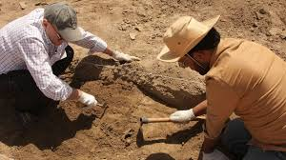  Artefacts  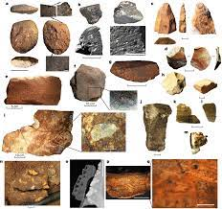  Prehistory  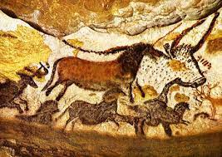  Domesticate  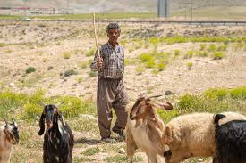 | Palaeolithic  Mesolithic  Neolithic  Neanderthal  Nomad  Celt  Quern  Smelting  Druid

