The Green Children
Year: 3

Term: Autumn 2

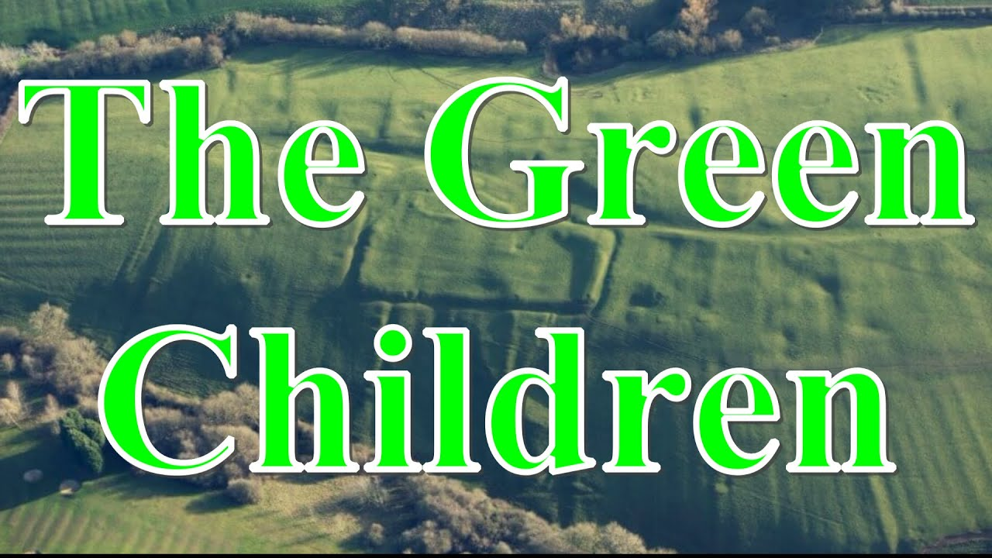
Tier 1 (Known Words) | Tier 2 (Sentence and Visual) | Tier 3
nutrients, ,  sugars, , ,  fat,  water,  skeleton,  bones,  muscles,  move,  skull,  ribs,  spine | Nutrition, 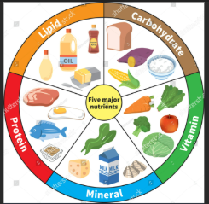  support,   protect, 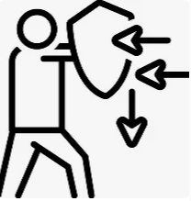  joints, 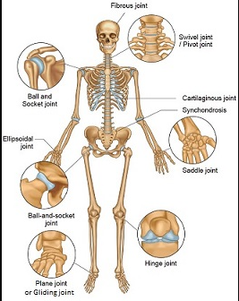 | Carbohydrates  Protein  Vitamins  fibre  minerals, ,

Science (Objectives) –

- compare how things move on different surfaces
- notice that some forces need contact between two objects, but magnetic forces can act at a distance
- observe how magnets attract or repel each other and attract some materials and not others
- compare and group together a variety of everyday materials on the basis of whether they are attracted to a magnet, and identify some magnetic materials
- describe magnets as having two poles
- predict whether two magnets will attract or repel each other, depending on which poles are facing.

Humanities (Geography/History – Objectives) R.E (unit)
Geography
What would it be like to live in Antarctica?

Locational know-identify the position and significance of latitude, longitude, Equator, Northern Hemisphere, Southern Hemisphere, Arctic and Antarctic Circle, the Prime/Greenwich Meridian and time zones (including day and night)

+ starting lessons- Arctic and Antarctica on a map- where is the Artic. Why is it not shown? Discussing that it is an ice sheet not a continent.

+ Latitude, longitude, equator

+ Time zones
RE
Christianity - God
Key Question (to be used all year): Who should we follow?
Focus Question (for this investigation): How (and why) have some people served God?

Arts (Art/DT) (Outcome and Objectives) (Music – Unit)
Art/DT
DT-Mechanical systems
Levers and linkages

Music –

I've been to Harlem
Maths (Lancashire Planning units)
Week 1 - Counting sequences and multiplication facts
Week 2 - Written and Mental Multiplication
Week 3 - Written and Mental division
Week 5 - Shape
Week 6 & 7 - Assess and review week.
ICT
Stop-frame animation
MFL (Unit)
All About Me
Health
PSHE (Unit)
Respecting ourselves and Others
P.E (Unit)
Gymnastics and Dance
Enrichment (Visits/Visitors/Parent Showcase)
Visit to the cenotaph

English (Objectives)
Text Types
Folk Tales
Instructions
Recount: Letters
Skill Focus
- Commas to demarcate clauses
- Range of conjunctions: when, while, before, after
- Inverted commas
- Determiners a and an
Talk Programme Strategies
Book talk
Vocabulary
Role-play
Oral retell of a story
Role-play (first lines drama)
Modelled and independent short writing opportunities
Character descriptions
Diary entries
Predictions
Alternative endings to chapters
Letters/postcards
Descriptions of objects
Paragraphs including dialogue
Modelled and independent writing outcome(s)
Innovated outcome of a folk tale based on a model
Recount: Letter in role
Instructions

