
WELCOME TO RECEPTION

Dear Parents/ Carers
My name is Mrs Novak and I am very excited to be your child’s teacher in September.
We will soon be arranging some ‘stay and play’ sessions where you and your child can meet the staff and explore our large classroom area. In the meantime, here is some key information that help to answer any questions you may have. ​​​
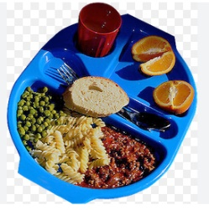
Lunches and snacks
For Reception and Key Stage 1, lunches are free and there are lots of hot and cold options. However, children can bring their own packed lunches if they prefer. Children are also provided with a fruit snack in the morning and fresh water is available throughout the day for children to drink.

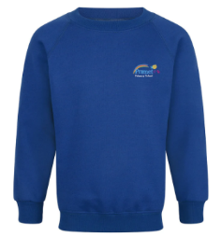
Spare Clothes and Water bottles
Please ensure your child’s name is in all their clothing, including coats, as this makes it much easier to identify items that go missing. Especially for the first few weeks please send your child to school with a change of clothes including underwear and socks – as accidents do happen. Your child may also want to bring a water bottle with them to school, please can these also be labelled with your child’s name.

School Times
Parents are welcome to accompany their child into school from 8.35 to help them settle in. Children should be collected at the end of the day at 3.10 from the classroom.

Communication
If you have any concerns or questions, I am available any day after school. We have a parent’s information board in the entrance hallway, which is updated regularly with different information. This information is also emailed and texted out through our school messaging service.
In the entrance hallway, we have a learning journey wall and book with updates about what your child has been learning each week, this information will also be available on the school website. We also use Tapestry, which is an online platform, allowing us to send you updates and photos of your child’s learning.

Phonics and reading books
In EYFS we learn to read through the use of phonics. We learn each letters individual sound and build these together to decode a word. Your child will soon be given a school reading book starting with wordless books. It’s important that you read with your child as often as possible to give them the best start in life. Here are some activities and ideas for sharing these books with your child:
- Look at the front cover, ask your child what they think the book is about?
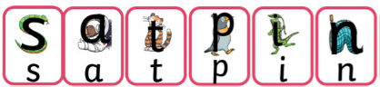
- Ask them to describe what they see in the pictures.
- Ask your child to find items in the book.
- After reading, ask your child to retell the story. Did they enjoy it?
Record any comments in your child’s reading record book, every time you read together.

Class Dojo
We use an online platform called Class Dojo to celebrate your child’s achievements at school. We will invite you to join when your child starts school and you can access this either online or by downloading the app.

If you require any further information, please feel free to contact us on:
Phone: 01282 864607
Or email the school office at: sbm@primet.lancs.sch.uk

See you soon

