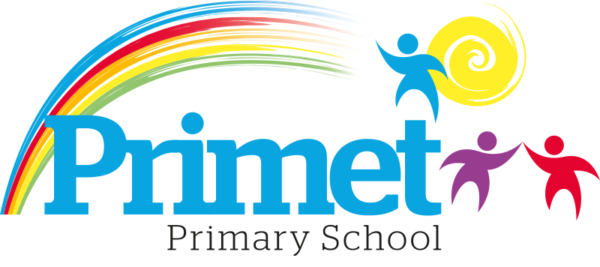
Sport Premium Funding statement 2024/2025

CONTEXT OF THE SCHOOL

The school is an average-sized Primary School with 183 (September 2024) pupils on roll. These numbers may change throughout the year.

Key features of the school

- 7 classes one form entry primary school.
- Socio-economic Taken from the 23/24 LSIP, Over deprivation index (A least E most deprived)
Education skills and training = E
Income = E
Employment = E
Health and Disability = E
Housing = A - because of close-proximity to public services
Crime = D
Living Environment = E
- Ethnic heritage, we have 12 different heritages at school;47% white/British, 28% Pakistani, Other white 7%, White and Asian 3%, other Asian 3% and 3% Other.
- Gender balance 47%Female 52% Male
- FSM 42% & 43%eligible for Pupil Premium funding. (EYFS PPG children to be included later once known)
- SEND 31%, 6 with EHCP 57 with SEN support. Likely to rise once EYFS included.
- CLA 1 families, 3 Early Help Plan
- Attendance:
Attendance including CME is 91.61% -0.42% increase.

- Mobility:
The following KS1 children were not in reception in this school at the end of that year:
Y1: 0 children:
Y2: 7 children: (11.29%)

The following KS2 children were not in Y2 in this school at the end of that year:
Y3: 1 child (0.8%)
Y4: 5 children: (4.16%)
Y5: 2 children: (1.66%)
Y6: 4 children: (3.33%)

Key information

Pupil summary | 2023/2024 |  | 2024/2025
Number of Eligible pupils | 190 | £17,630 | 183 | £17,630

Record of Sport premium funding Spending 2024/2025 Report

Priorities for the spending for Sport Premium Funding

Item/Project | Cost | Objective | Impact
HLTA coaching in the afternoons | £14,753 | To provide focused PE sessions for all year groups during the afternoons.
HLTA coaching for after school activities | £1,070 | To provided focus coaching of children to up skills the children in representing school at local competitions.
To use local coaches from the local community. Cricket and Rugby, Bike ability and Dance | Free | To provided extra opportunities to improve the children’s sporting skills. To represent school in competitions.
To join Sports partnership in the Pendle area | £1,807 | To be in the sports partnership to access all out of school competitions for all children no matter of ability

Total spending £17,630 = Total £ 17,630

Written: September 2024
Reviewed July 2025

