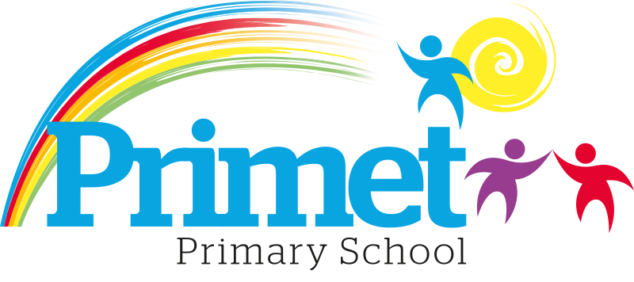
Pupil Premium Strategy statement 2024/2025

CONTEXT OF THE SCHOOL

The school is an average-sized Primary School with 183 (September 2024) pupils on roll. These numbers may change throughout the year.

Key features of the school

- 7 classes one form entry primary school.
- Socio-economic Taken from the 23/24 LSIP, Over deprivation index (A least E most deprived)
Education skills and training = E
Income = E
Employment = E
Health and Disability = E
Housing = A - because of close-proximity to public services
Crime = D
Living Environment = E
- Ethnic heritage, we have 12 different heritages at school;47% white/British, 28% Pakistani, Other white 7%, White and Asian 3%, other Asian 3% and 3% Other.
- Gender balance 47%Female 52% Male
- FSM 42% & 43%eligible for Pupil Premium funding. (EYFS PPG children to be included later once known)
- SEND 31%, 6 with EHCP 57 with SEN support. Likely to rise once EYFS included.
- CLA 1 families, 3 Early Help Plan
- Attendance:
Attendance including CME is 91.61% -0.42% increase.

- Mobility:
The following KS1 children were not in reception in this school at the end of that year:
Y1: 0 children:
Y2: 7 children: (11.29%)

The following KS2 children were not in Y2 in this school at the end of that year:
Y3: 1 child (0.8%)
Y4: 5 children: (4.16%)
Y5: 2 children: (1.66%)
Y6: 4 children: (3.33%)

Key information

Pupil summary | 2023/2024 |  | 2024/2025
Number of Eligible pupils | 81 | 48% High | 83 | 45% High
Number of Eligible pupils | 81 | £119,312 | 83 | £120,765

Cohort information for 2024/2025

 | PPG Pupils | PPG Boys | PPG Girls | PPG SEND | NOR | PPG %
EYFS | 7 | 3 | 4 | - | 20 | 35%
Y1 | 7 | 3 | 4 | 2 | 22 | 32%
Y2 | 10 | 5 | 5 | 3 | 20 | 45%
Y3 | 19 | 15 | 4 | 5 | 31 | 61%
Y4 | 12 | 5 | 7 | 12 | 30 | 40%
Y5 | 15 | 10 | 5 | 12 | 30 | 50%
Y6 | 13 | 8 | 5 | 12 | 30 | 43%
Total | 83 | 49 | 34 | 46 | 183 | 45%

Record of PPG Spending 2024/2025 Impact Report

Priorities for the spending for Pupil Premium children within the school is to close the learning gap for all disadvantaged children who access Pupil Premium funding. This spending has been directed towards improving attainment in Reading, Writing and Maths which links into our SIP 2024/2025.

Item/Project | Cost | Objective | Impact
Trips | £3,000 | To cover the cost of trip for children unable to afford the costs.
Catch up in year 6 after half term Autumn and spring term | £1,920  X6 session at £20  X6 groups =£720  X10 session at £20  X6 groups =£1,200 | To boost confidence and accelerate the progress of targeted individuals in English and Maths to increase the number of age-related expectations at the end of year 6. Targeted in the Autumn 2 and spring term.
Out of school provision, resources and staffing costs. | £5,000 | To support families with the provision in school to improve quality of life.
Intervention Groups within all classes including Acquisition in English x1 HLTA, Phonics and other oral interventions  X6 TA’s L2/3 for working in the mornings.  SSA top up class interventions | £18,755  £79,915  £8,500 | To boost confidence of children who are not yet proficient in English.  To deepen the knowledge and understanding of targeted pupils in Maths and English.  To improve the language and communication skills of targeted pupils.  To improve end of yearly assessments outcomes.

Access to breakfast | £100 for one week  May 2025 | To ensure Y2 and Y6 pupil premium children have breakfast  during SATs week & are all in school  on time
Y5/Y6 – Hygiene pack including – shampoo, shower  gel,  toothpaste/brush, deodorant, flannel, drawstring bag (£6 each) | £300 | To ensure that PP children have good hygiene habits. Year 5 and Year 6.
Resources to support interventions and catch up groups | £2,000 | CGP resources across the school for interventions and catch up groups including PP children.
Trophies | £400  £600 | End of year trophies to build the self-esteem of the children.  Bikes for attendance
Total spent: £120,490 plus Contingency £275 = £120,765

Written: September 2024
Reviewed June 2025

