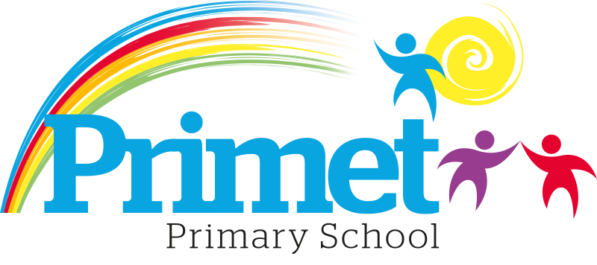
Pupil Premium Strategy statement 2023/2024

CONTEXT OF THE SCHOOL

The school is a average-sized Primary School with 188 (September 2023) pupils on roll.

Key features of the school

- 7 classes one form entry primary school.
- Socio-economic Taken from the 22/23 LSIP, Over deprivation index (A least E most deprived)
Education skills and training = E
Income = E
Employment = E
Health and Disability = E
Housing = A - because of close-proximity to public services
Crime = D
Living Environment = E
- Ethnic heritage, we have 12 different heritages at school;47% white/British, 27% Pakistani, Other white 8%, White and Asian 3%, other Asian 2% and 12% Other.
- Gender balance 44% Female 56% Male
- FSM 47% & 48% eligible for Pupil Premium funding. (EYFS PPG children to be included later once known)
- SEND 30%, 6 with EHCP 45 with SEN support. Likely to rise once EYFS included.
- CLA 0 families, 8 CAF’s
- Attendance:
Attendance including CME is 92.1% 2022/2023 -0.55% reduction.

- Mobility:
The following KS1 children were not in reception in this school at the end of that year:
Y1: 4 children: (25%)
Y2: 4 children: (13%)

The following KS2 children were not in Y2 in this school at the end of that year:
Y3: 5 children: (17%)
Y4: 5 children: (17%)
Y5: 7 children: (22%)
Y6: 13 children: (39%)

Key information

Pupil summary | 2021/2022 |  | 2022/2023 |  | 2023/2024
Number of Eligible pupils | 63 | 31%  High | 65 | 33.2%High | 81 | 48% High
Number of Eligible pupils | 63 | £88,355 | 65 | £90,025 | 81 | £119,312

Cohort information for 2023/2024

 | PPG Pupils | PPG Boys | PPG Girls | PPG SEND | NOR | PPG %
EYFS | 0 | 0 | 0 | 0 | 21 | 0%
Y1 | 7 | 5 | 2 | 3 | 16 | 44%
Y2 | 18 | 13 | 5 | 4 | 30 | 60%
Y3 | 11 | 6 | 5 | 2 | 29 | 38%
Y4 | 14 | 10 | 4 | 4 | 29 | 48%
Y5 | 15 | 6 | 9 | 2 | 32 | 47%
Y6 | 16 | 8 | 8 | 3 | 33 | 48%
Total | 81 | 48 | 33 | 18 | 190 | 43%  No EYFS 48%

Record of PPG Spending 2023/2024 Impact Report

Priorities for the spending for Pupil Premium children within the school is to close the learning gap for all disadvantaged children who access Pupil Premium funding. This spending has been directed towards improving attainment in Reading, Writing and Maths which links into our SIP 2023/2024.

Item/Project | Cost | Objective | Impact
1:1 tuition or small group work for pupils in Y2 reading recovery | £1,000 | To boost confidence and accelerate the progress of targeted individuals in Reading | PP children achieved 58% in reading in year 2 at ARE. Nott PP achieved 100% at ARE. However, progress was at a similar rate to non-PP children. Some PP children achieved GD with 7% of all pupils achieving this for the first time 5 years.
Apprentice teacher in EYFS to support learning to improve outcomes. | £24,947 | To improve GLD to above 65% | GLD for 2024 was 59% which is a decrease from 63% in 2023. However, the cohort size was bigger and there were more children with SEND for 2024.  ELG has decreased for reading 68.8% in 2023 to 63.6% in 2024  ELG has risen for Communication 68.8% in 2023 to 63.6% in 2024  The improvement is especially noticeable in girls from 25% to 71.4% in reading.
Intervention Groups within all classes including Acquisition in English x1 HLTA, Phonics and other oral interventions  X6 TA’s L2/3 for working in the mornings. | £17,196  £73366.50 | To boost confidence of children who are not yet proficient in English.  To deepen the knowledge and understanding of targeted pupils in Maths and English.  To improve the language and communication skills of targeted pupils.  . | Early identification of communication and interaction difficulties has proved beneficial to offer intervention to ensure Speech and Language does not limit or hinder learning.  This improved Y1 phonics outcomes to 100% 2024 from 72.4% 2023. This puts school in the top 1% nationally.  It has also improved attainment in Reading and Writing.  Targeted extra intervention in Early reading for Year 1 and Year 2 in 2023/2024. This has supported pupil premium children and the End of key stage scores has closed the attainment gap. Pupil Premium children do better than non-pupil premium children in end of year testing in Year 1,3,4 and 5 in reading.  Premium children do better than non-pupil premium children in end of year testing in Year 3,4 and 5 in writing.  Premium children do better or the same as non-pupil premium children in end of year testing in Year 3,4, 5 and 6 in maths.

Access to breakfast | £100 for one week  May 2023 | To ensure Y2 and Y6 pupil premium children have breakfast  during SATs week & are all in school  on time | All PP children attended breakfast club and were on time for their tests. Children were relaxed and calm before tests. See below for progress and results.
Y5/Y6 – Hygiene pack including – shampoo, shower  gel,  toothpaste/brush, deodorant, flannel, drawstring bag (£6 each) | £300 | To ensure that PP children have good hygiene habits. Year 5 and Year 6. | All children in Year 5 and Year 6 received a kit which was used by most children daily. Hygiene habits improved after this.  Central school resource has been created so all children can access these items if required.
Resources to support interventions and catch up groups | £2,000 | CGP resources across the school for interventions and catch up groups including PP children. | Resources bought and the impact has been outlined in other areas of spending.
Trophies | £400 | End of year trophies to build the self esteem of the children. | All trophies were bought and the children gained a lot of pleasure in receiving these at the end of the year celebrations.
Total spent: £119,309.50 plus Contingency £2.50 = 119,312

Written: September 2023
Reviewed June 2024

