

Mental Health and Emotional Wellbeing Policy for Pupils
2024 / 2026
Policy Leader | Mr Christopher Holmes
Last Updated | September 2024
Approved by the Governing Body
Date of Review | To be reviewed every 2 years as a minimum.  Next review date: September 2026

Policy statement
At Primet Primary School, we are committed to promoting positive mental health and emotional wellbeing to all students, their families and members of staff and governors. Our open culture allows students’ voices to be heard, and through the use of effective policies and procedures we ensure a safe and supportive environment for all affected - both directly and indirectly - by mental health issues.
Scope
This policy describes the school’s approach to promoting positive mental health and wellbeing and is intended as guidance for all staff including non-teaching staff and governors. It should be read in conjunction with our medical policy in cases where a student’s mental health overlaps with or is linked to a medical issue, the SEND policy where a student has an identified special educational need and the safeguarding policy in relation to prompt action and wider concerns of vulnerability.
It is widely recognised that a child’s emotional health and wellbeing influences their cognitive development and learning, as well as their physical and social health and their mental wellbeing in adulthood. The department for Education recognises that, “in order to help their pupils succeed: schools have a role to play in supporting them to be resilient and mentally healthy”. (World Health Organization 2014)

“Mental health is a state of well-being in which every individual realises his or her own potential, can cope with the normal stresses of life, can work productively and fruitfully, and is able to make a contribution to her or his community.” (World Health Organization 2014)

Policy Aims
At our school, we aim to promote positive mental health for every child, parent / carer and staff. We pursue this aim using both universal, whole school approaches and specialised, targeted approaches aimed at identified pupils and families.
The following diagram presents eight principles to promote emotional health and wellbeing in school.

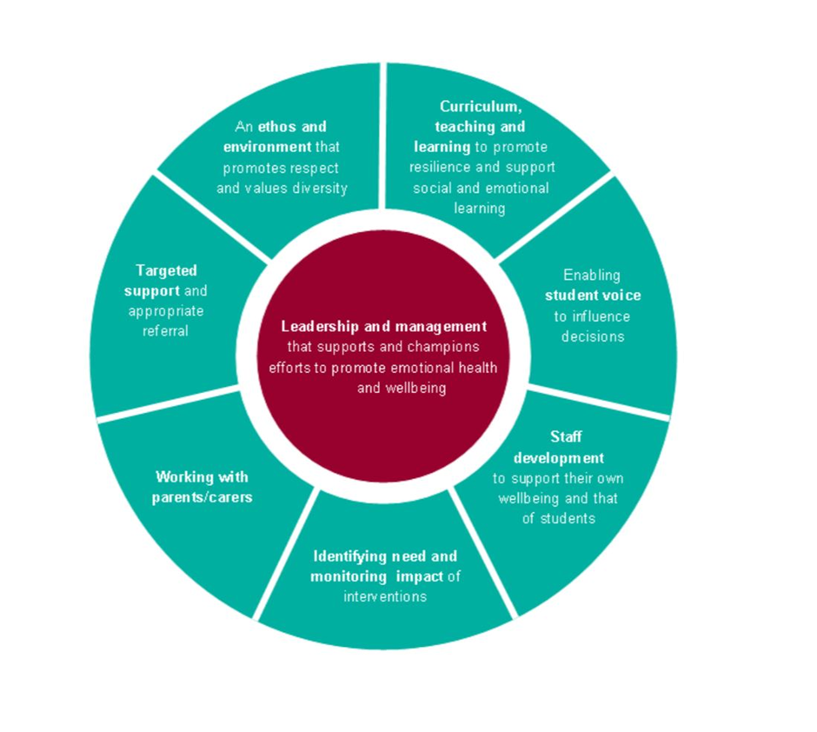
The eight identified principles will underpin the approaches used to support the development and integration of wellbeing strategies at Primet Primary.
In addition to promoting positive mental health, we aim to recognise and respond to mental ill health. We recognise as a school that by developing and implementing practical, relevant and effective mental health procedures we can promote a safe and stable environment for children affected both directly, and indirectly by mental ill health.
- Promote positive mental health and emotional wellbeing in all staff and students.
- Increase understanding and awareness of common mental health issues.
- Enable staff to identify and respond to early warning signs of mental ill health in students.
- Enable staff to understand how and when to access support when working with young people with mental health issues.
- Provide the right support to students with mental health issues, and know where to signpost them and their parents/carers for specific support.
- Develop resilience amongst students and raise awareness of resilience building techniques.
- Raise awareness amongst staff and gain recognition from SLT that staff may have mental health issues, and that they are supported in relation to looking after their wellbeing; instilling a culture of staff and student welfare where everyone is aware of signs and symptoms with effective signposting underpinned by behaviour and welfare around school.
Key staff members
All staff has a responsibility to promote the mental health of students, however key members of staff have specific roles to play:
- Family Support Worker/Mental Health First Aider/Deputy Safeguarding Lead– Mrs Eccles
- SENCO – Miss Dawson
- Head Teacher/Mental Health First Aid Champion/Designated Safeguarding Lead – Mr Holmes
- PSHRE Lead – Mr Haworth
If a member of staff is concerned about the mental health or wellbeing of student, in the first instance they should speak to the deputy safeguarding lead.
If there is a concern that the student is high risk or in danger of immediate harm, the school’s child protection procedures should be followed.
If the child presents a high-risk medical emergency, relevant procedures should be followed, including involving the emergency services if necessary.
Individual Care Plans
When a pupil has been identified as having cause for concern, has received a diagnosis of a mental health issue, or is receiving support either through ELCAS (East Lancashire Child & Adolescent Service) or another organisation, it is recommended that an Individual Care Plan should be drawn up. The development of the plan should involve the pupil, parents, and relevant professionals.
Suggested elements of this plan include:
- Details of the pupil’s situation/condition/diagnosis
- Special requirements or strategies, and necessary precautions
- Medication and any side effects
- Who to contact in an emergency
- The role the school and specific staff

Teaching about mental health
The skills, knowledge and understanding our students need to keep themselves - and others - physically and mentally healthy and safe are included as part of our PSHRE curriculum and our peer mentoring programme.
We will follow the guidance issued by the PSHRE Association to prepare us to teach about mental health and emotional health safely and sensitively.
https://www.pshe-association.org.uk/curriculum-and-resources/resources/guidance-preparing-teach-about-mental-health-and emotional wellbeing
Incorporating this into our curriculum at all stages is a good opportunity to promote students’ wellbeing through the development of healthy coping strategies and an understanding of students’ own emotions as well as those of other people.
Additionally, we will use such lessons as a vehicle for providing students who do develop difficulties with strategies to keep themselves healthy and safe, as well as supporting students to support any of their friends who are facing challenges.
Signposting
We will ensure that staff, students and parents/carers are aware of the support and services available to them, and how they can access these services.
Within the school (noticeboards, toilets etc.) and through our communication channels (newsletters, website), we will share and display relevant information about local and national support services and events.
The aim of this is to ensure students understand:
- What help is available
- Who it is aimed at
- How to access it
- Why should they access it
- What is likely to happen next
Sources or support at school and in the local community
School Support
Here at Primet Primary School we aim to maximise children’s learning through promoting good mental health and wellbeing across the school. Primet Primary School have various interventions and support for children to access in order to promote their emotional wellbeing and build on resilience.
Sensory Tent/Sensory room
These provide a safe space for children who are feeling overwhelmed with their current environment.
Family Support Worker
Mrs Eccles is available throughout the day for any child to approach and speak with regarding any uncomfortable emotions/feelings they may be experiencing. Direct work sessions are offered to educate pupils on mental health and strategies practised to promote the young person feeling confident in dealing with their emotions healthily.
Worry Box
At Primet Primary we believe that children will learn best when they are free from worries. In order to support all our children who, have a worry or a concern about anything, we have Worry Boxes available within individual classrooms. Every child can share a worry in confidence by posting a note in one of the Worry Boxes.
Lego Therapy
Signposting to Lego® therapy is a social development program for children with autism spectrum disorder (ASD) or other social communication difficulties.
Nurture/Mindfulness Lunchtime Group
This is a drop-in group available to all pupils throughout the lunchtime period focusing on building children’s social skills and emotional awareness. These are skills that help children with understanding their own feelings as well as the feelings of their family, friends and teachers. Within the group there are mindfulness colouring resources available along with breathing exercises, meditation and ‘grounding’ activities to support children return to the present moment and in control of their emotions whilst continuing to learn practical and effective strategies to manage their emotions.
Lunch Clubs
A variety of lunchtime activities supervised by staff are available for children to participate in including Gardening, Reading and Board Games. These groups help promote resilience and team work which help promote positivity.
PSHRE
Within each class teachers ensure that pupils receive further emotional support through PSHRE lessons (Personal, Social, Health, & Religious Education).
Mental Health in Schools Team - (MHST)
Primet Primary School takes part in regular case supervisions with an NHS Educational Mental Health Practitioner (EMHP) who is able to offer support and advice on how best to support children and families who may need additional mental health support. They advise on suitable referrals and are able to deliver evidence-based early interventions for children and young people and parents/carers in educational settings who are displaying low level emotional difficulties. MHST also offer termly workshops and assemblies in school to promote wellbeing topics such as Worry Management and 5 Ways to Wellbeing..
Staff Training
All members of staff including, teachers, teaching assistants, welfare staff, office staff and volunteers are trained regularly with strategies and understanding of children’s mental health.
Regular updates are also distributed to ensure that all members of staff are up to date with their knowledge and practical skills.
Local Support
In Pendle there are a range of organisations and groups offering support, specialising in children and young people’s mental health wellbeing. These partners deliver accessible support to children, young people and their families, whilst working with professionals to reduce the range of mental health issues through prevention, intervention, training and participation. Warning Signs
Staff may become aware of warning signs which indicate a student is experiencing mental health or emotional wellbeing issues. These warning signs should always be taken seriously and staff observing any of these warning signs should alert (insert name of mental health first aider).
Possible warning signs, which all staff should be aware of include:
- Physical signs of harm that are repeated or appear non-accidental
- Changes in eating / sleeping habits
- Increased isolation from friends or family, becoming socially withdrawn
- Changes in activity and mood
- Lowering of academic achievement
- Talking or joking about self-harm or suicide
- Abusing drugs or alcohol
- Expressing feelings of failure, uselessness or loss of hope
- Changes in clothing – e.g. long sleeves in warm weather
- Secretive behaviour
- Skipping PE or getting changed secretively
- Lateness to, or absence from school
- Repeated physical pain or nausea with no evident cause
- An increase in lateness or absenteeism
Targeted support
We recognise some children and young people are at greater risk of experiencing poorer mental health. For example, those who are in care, young carers, those who have had previous access to ELCAS, those living with parents/carers with a mental illness and those living in households experiencing domestic violence.
We work closely with school nurses and their teams in supporting the emotional and mental health needs of school-aged children and are equipped to work at community, family and individual levels. Their skills cover identifying issues early, determining potential risks and providing early intervention to prevent issues escalating.
We ensure timely and effective identification of students who would benefit from targeted support and ensure appropriate referral to support services by:
- Providing specific help for those children most at risk (or already showing signs) of social, emotional, and behavioural problems;
- Working closely with Children and Families Wellbeing Service, Lancashire County Council Children’s Services, ELCAS and other agencies services to follow various protocols including assessment and referral;
- Identifying and assessing children who are showing early signs of anxiety, emotional distress, or behavioural problems;
- Discussing options for tackling these problems with the child and their parents/carers. Agree an Individual Care Plan to offer targeted support.
- Providing a range of interventions that have been proven to be effective.
According to the child’s needs;
- Ensure young people have access to pastoral care and support, as well as specialist services, so that emotional, social and behavioural problems can be dealt with as soon as they occur;
- Provide young people with clear and consistent information about the opportunities available for them to discuss personal issues and emotional concerns. Any support offered should take account of local community and education policies and protocols regarding confidentiality;
- Provide young people with opportunities to build relationships, particularly those who may find it difficult to seek support when they need it; and
- The identification, assessment, and support of young carers under the statutory duties outlined in the Children & Families Act 2014.

Managing disclosures
If a pupil chooses to disclose concerns about themselves, or a friend, to any member of staff, the response will be calm, supportive and non-judgemental.
All disclosures should be recorded confidentially on the student’s personal file on CPOMS, details to include;
- Date
- Name of member of staff to whom the disclosure was made
- Nature of the disclosure & main points from the conversation
- Agreed next steps
This information will be shared with designated / deputy safeguarding leads and the mental health lead.
Confidentiality
If a member of staff feels it is necessary to pass on concerns about a pupil to either someone within or outside of the school, then this will be first discussed with the pupil.
We will tell them:
- Who we are going to tell
- What we are going to tell them
- Why we need to tell them
- When we’re going to tell them
Ideally, consent should be gained from the pupil first, however, there may be instances when information must be shared, such as pupils up to the age of 16 who are in danger of harm.
It is important to also safeguard staff emotional wellbeing. By sharing disclosures with a colleague this ensures one single member of staff isn’t solely responsible for the student. This also ensures continuity of care should staff absence occur and provides opportunities for ideas and support.
If a pupil gives us reason to believe that they are at risk, or there are child protection issues, parents should not be informed, but the child protection procedures should be followed.
Whole school approach
Working with parents/carers
If it is deemed appropriate to inform parents there are questions to consider first:
- Can we meet with the parents/carers face-to-face?
- Where should the meeting take place – some parents are uncomfortable in school premises so consider a neutral venue if appropriate.
- Who should be present – students, staff, parents etc.?
- What are the aims of the meeting and expected outcomes?
We are mindful that for a parent, hearing about their child’s issues can be upsetting and distressing. They may therefore respond in various ways which we should be prepared for and allow time for the parent to reflect and come to terms with the situation.
Signposting parents to other sources of information and support can be helpful in these instances. At the end of the meeting, lines of communication should be kept open should the parents have further questions or concerns. Booking a follow-up meeting or phone call might be beneficial at this stage.
Ensure a record of the meeting and points discussed/agreed are added to the pupil’s record and an Individual Care Plan created if appropriate.
Supporting parents
We recognise the family plays a key role in influencing children and young people’s emotional health and wellbeing; we will work in partnership with parents and carers to promote emotional health and wellbeing by:
- Ensuring all parents are aware of and have access to promoting social and emotional wellbeing and preventing mental health problems;
- Highlighting sources of information and support about common mental health issues through our communication channels (website, newsletters etc.);
- Offering support to help parents or carers develop their parenting skills. This may involve providing information or offering small, group-based programmes run by our Children and Family Wellbeing Service or other appropriately trained health or education practitioners; and
- Ensuring parents, carers and other family members living in disadvantaged circumstances are given the support they need to participate fully in activities to promote social and emotional wellbeing. This will include support to participate in any parenting sessions, by offering a range of times for the sessions or providing help with transport and childcare. We recognise this might involve liaison with family support agencies.
Supporting Peers
When a student is suffering from mental health issues, it can be a difficult time for their friends who may want to support but do not know how. To keep peers safe, we will consider on a case by case basis which friends may need additional support. Support will be provided in one to one or group settings and will be guided by conversations by the student who is suffering and their parents with whom we will discuss:
- What it is helpful for friends to know and what they should not be told
- How friends can best support
- Things friends should avoid doing / saying which may inadvertently cause upset
- Warning signs that their friend needs help (e.g. signs of relapse)
Additionally, we will want to highlight with peers:
- Where and how to access support for themselves
- Safe sources of further information about their friend’s condition
- Healthy ways of coping with the difficult emotions they may be feeling
Training
As a minimum, all staff will receive regular training about recognising and responding to mental health issues as part of their regular safeguarding training to enable them to keep pupils safe. A nominated member of staff will receive professional Mental Health First Aid training or equivalent.
We will host relevant information on our website for staff who wish to learn more about mental health. The MindEd learning portal provides free online training suitable for staff wishing to know more about a specific issue.
Training opportunities for staff who require more in-depth knowledge will be considered as part of our performance management process and additional CPD will be supported throughout the year where it becomes appropriate.

Reviewed: September 2024
Next review: September 2026

