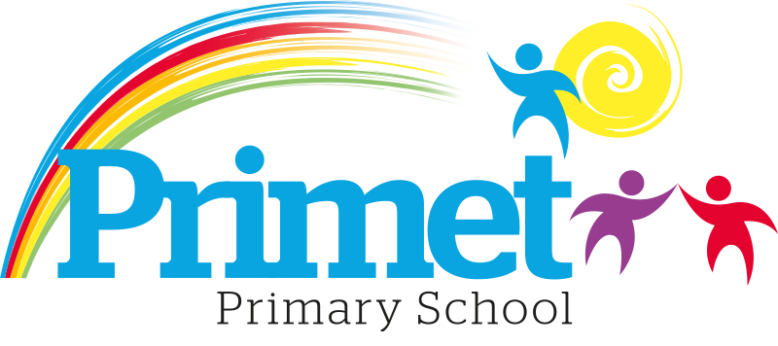

Primet Home Learning Policy

The curriculum at Primet Primary School (found on www.primet.lancs.sch.uk) will ensure that all learners leave school as resilient and confident individuals, who lead healthy and happy lives. Our core values of kindness, respect and trust influence the actions and decisions made by the entire school community.
Through an enriched and bespoke curriculum that utilises the local and wider community, pupils will be ambitious with high aspirations for themselves and others. Pupils appreciate and celebrate the school’s diverse community, demonstrating spiritual, moral and cultural awareness and understanding. They will be well-prepared for the world of work, through the acquisition of the knowledge and skills necessary to become fully literate and numerate. Pupils will be active enquirers, who possess the creativity and ability to think critically to solve problems and make connections in an ever-changing world. With a growth mind set, pupils are prepared to take risks. They see mistakes as a learning opportunity and challenge as an enjoyable struggle.
As emotionally intelligent individuals, pupils will have an understanding of their own and others’ needs that will equip them to take responsibilities and lead at a local, national and global level.
Home Learning is but one aspect of what being a pupil at Primet Primary School is and how the school aims to ensure that all children successfully achieve our intent. We also acknowledge the important role of play and free time in a child’s growth and development and have therefore created a home learning policy that enables all of our learners to embed essential skills needed for life.
Through this policy we aim to:
- Ensure consistency of approach to home learning throughout the school.
- To use home learning as a tool to help continue to raise standards of attainment.
- Ensure that parents are clear about what their child is expected to do.
- To practise or consolidate basic skills and knowledge, especially in mathematics and English.
- Encourage children to develop the responsibility, confidence and self-discipline needed to study independently. To prepare Year 6 pupils for the transfer to secondary school.

Home Learning

All children are expected to read every night as part of their weekly homework. Reading books are given to children based upon their current phonics ability. In addition to this, weekly homework activities are identified for the specific key stages as can be seen below:
EYFS
Phonics
KS1
Phonics and Spelling practice spelling patterns and statutory words.
KS2
Spelling for that week including spelling patterns and statutory words.
Times table homework based upon the current times table that week.

Expectations to times table knowledge is as follows:
Year Group | End of Year Expectation
Y1 | Counting in 2, 5 and 10
Y2 | X2, X3, X5, X10
Y3 | X2, X3, X4, X5, X8, X10, X11
Y4  Y5  Y6 | X2, x3, x4, x5, x6, x7, x8, x9, x10, x11, 12  (and corresponding division facts e.g.  6x3=18, 3x6=18, 18÷6=3, 18÷3=6).

Children should not be limited to the guidelines above and can learn any of the times tables and division facts above regardless of their age.

Roles and Responsibilities
Governors will:

- Set, discuss and review the policy on a regular basis.

The Headteacher and Deputy Headteacher will:

- Monitor the implementation of this policy.
- Provide all stakeholders with a clear policy for home learning.
- Ensure the policy is fully and consistently followed.
- Listen to views about home learning from the children, staff and parents.
- Monitor Home Learning menus.

Staff will:

- Set Home work weekly and ensure that reading books are changed regularly.

Parents will:

- Encourage their child to complete home work.
- Ensure their child hands in the home learning on time.
- Provide a quiet place for their child to complete home learning.
- Get involved with their child’s learning but avoid doing it for them.

Children will:

- Make sure they understand the home work.
- Complete their home learning to the best of their ability.

Sharing the Policy

This policy will be shared with all stakeholders and a copy will be posted on the school website for future reference.
This policy was reviewed in July 2024 and will be reviewed again in July 2025.

