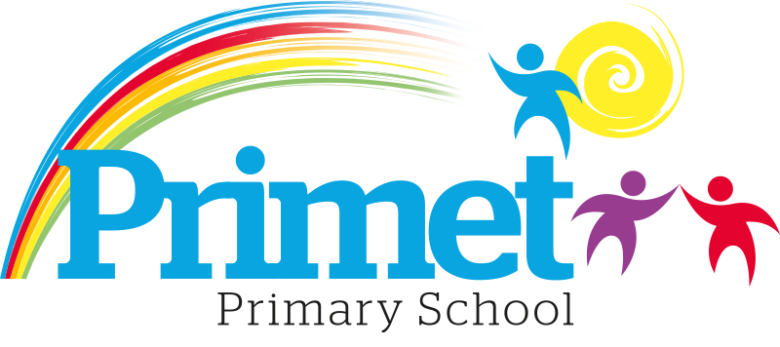
Catch up Funding Strategy statement 2023/2024

CONTEXT OF THE SCHOOL

The school is a average-sized Primary School with 188 (September 2023) pupils on roll.

Key features of the school

- 7 classes one form entry primary school.
- Socio-economic Taken from the 22/23 LSIP, Over deprivation index (A least E most deprived)
Education skills and training = E
Income = E
Employment = E
Health and Disability = E
Housing = A - because of close-proximity to public services
Crime = D
Living Environment = E
- Ethnic heritage, we have 12 different heritages at school;47% white/British, 27% Pakistani, Other white 8%, White and Asian 3%, other Asian 2% and 12% Other.
- Gender balance 44% Female 56% Male
- FSM 47% & 48% eligible for Pupil Premium funding. (EYFS PPG children to be included later once known)
- SEND 30%, 6 with EHCP 45 with SEN support. Likely to rise once EYFS included.
- CLA 0 families, 8 CAF’s
- Attendance:
Attendance including CME is 92.1% 2022/2023 -0.55% reduction.

- Mobility:
The following KS1 children were not in reception in this school at the end of that year:
Y1: 4 children: (25%)
Y2: 4 children: (13%)

The following KS2 children were not in Y2 in this school at the end of that year:
Y3: 5 children: (17%)
Y4: 5 children: (17%)
Y5: 7 children: (22%)
Y6: 13 children: (39%)

Key information

Pupil summary | 2022/2023 | 2023/2024
190 pupils | £9,860 | £7,616

Cohort information for 2023/2024

 | PPG Pupils | PPG Boys | PPG Girls | PPG SEND | NOR | PPG %
EYFS | 0 | 0 | 0 | 0 | 21 | 0%
Y1 | 7 | 5 | 2 | 3 | 16 | 44%
Y2 | 18 | 13 | 5 | 4 | 30 | 60%
Y3 | 11 | 6 | 5 | 2 | 29 | 38%
Y4 | 14 | 10 | 4 | 4 | 29 | 48%
Y5 | 15 | 6 | 9 | 2 | 32 | 47%
Y6 | 16 | 8 | 8 | 3 | 33 | 48%
Total | 81 | 48 | 33 | 18 | 190 | 43%  No EYFS 48%

Record of Catch up Funding Spending 2023/2024 Impact Report

Priorities for the spending for Catch up funding children within the school is to close the learning gap for all children who the funding is targeted at funding. This spending has been directed towards improving attainment in Reading, Writing and EYFS which links into our SIP 2023/2024.

Item/Project | Cost | Objective | Impact
1:4 tuition or small group work for pupils in Y5 and Y6. Autumn term  Targeted intervention with the children who are just below age expected goals in core subjects for the year. | X10 session at £20= £200  X12 groups =£2,400 | Spring/Summer term.  To boost confidence and accelerate the progress of targeted individuals in English and Maths to increase the number of age-related expectations at the end of Key Stage Two. Targeted year 5 and year 6 in the spring term. These children are targeted from Autumn assessments.  Children will be tracked on the outcomes at the spring and EOKS assessments.
1:4 tuition or small group work for pupils in Y5 and and Y6. Spring Term  Targeted intervention with the children who are just below age expected goals in core subjects for the year. | X10 session at £20= £200  X12 groups =£2,400 | Spring term  To boost confidence and accelerate the progress of targeted individuals in English and Maths to increase the number of age-related expectations at the end of year 5. Targeted year 1 and year 5 in the summer term.  Children will be tracked on the outcomes at the spring and EOKS assessments.
1:4 tuition or small group work for pupils in Y4 and Y5. Summer Term | X7 session at £20= £200  X8 groups =£1,120 | To be decided after the Spring assessment.
Reading corners in Key Stage 2 to improve the love for reading. | £1,000 | To improve the love of reading in KS2

Total spent: £6,920 plus Contingency £ 696= £7,616

Written: September 2023
Reviewed: June 2024

