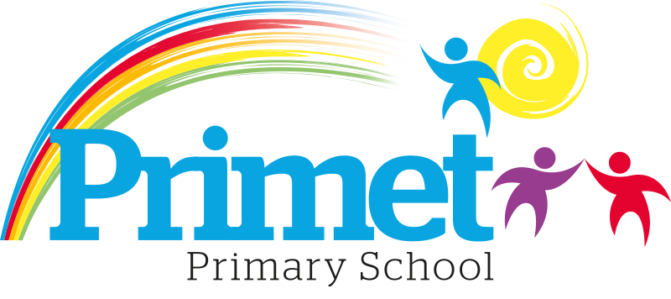
Catch up Funding Strategy statement 2022/2023

CONTEXT OF THE SCHOOL

The school is a average-sized Primary School with 195 (September 2021) pupils on roll.

Key features of the school

- 7 classes one form entry primary school.
- Socio-economic Taken from the 18/19 LSIP, Over deprivation index (A least E most deprived)
Education skills and training = E
Income = E
Employment = E
Health and Disability = E
Housing = A - because of close-proximity to public services
Crime = E
Living Environment = E
- Ethnic heritage, we have 12 different heritages at school;46% white/British, 28% Pakistani, Other white 8%, White and Asian 2%, other Asian 3%, Roma 2% and 11% Other.
- Gender balance 47.37% Female 52.63% Male
- FSM 40% & 40% eligible for Pupil Premium funding. (EYFS PPG children to be included later once known)
- SEND 19%, 3 with EHCP 34 with SEN support. Likely to rise once EYFS included.
- CLA 0 families, 8 CAF’s
- Attendance:
Attendance including CME is 92.65% 2021/2022 -2.88% reduction (September 2020 to March 2021 was 95.53%)
Attendance excluding CME is 92.65% 2021/2022, this is closing the gap with National Average.

- Mobility:
The following KS1 children were not in reception in this school at the end of that year:
Y1: 4 children: (13%)
Y2: 7 children: (27%)

The following KS2 children were not in Y2 in this school at the end of that year:
Y3: 12 children: (40%)
Y4: 12 children: (39%)
Y5: 17 children: (50%)
Y6: 20 children: (67%)

Key information

Pupil summary | 2022/2023
190 pupils | £9,860

Cohort information for 2022/2023

 | PPG Pupils | PPG Boys | PPG Girls | PPG SEND | NOR | PPG %
EYFS | 0 | 0 | 0 | 1 | 12 | 0%
Y1 | 17 | 12 | 5 | 3 | 30 | 57%
Y2 | 9 | 5 | 4 | 4 | 26 | 19%
Y3 | 15 | 10 | 5 | 2 | 30 | 50%
Y4 | 15 | 9 | 6 | 4 | 31 | 48%
Y5 | 13 | 6 | 7 | 2 | 33 | 39%
Y6 | 10 | 5 | 5 | 3 | 30 | 33%
Total | 79 | 47 | 32 | 19 | 192 | 38%

Record of Catch up Funding Spending 2022/2023 Impact Report

Priorities for the spending for Catch up funding children within the school is to close the learning gap for all children who the funding is targeted at funding. This spending has been directed towards improving attainment in Reading, Writing and EYFS which links into our SIP 2022/2023.

Item/Project | Cost | Objective | Impact
1:4 tuition or small group work for pupils in Y2, Y5 and Y6. Autumn term  Targeted intervention with the children who are just below age expected goals in core subjects for the year. | X10 session at £20= £200  X12 groups =£2,400  Resources £3600 | Spring/Summer term.  To boost confidence and accelerate the progress of targeted individuals in English and Maths to increase the number of age-related expectations at the end of Key Stage one and two. Targeted year 2 and year 6 in the spring term. These children are targeted from Autumn assessments.  CGP bought for work with interventions across all year groups.  Children will be tracked on the outcomes at the spring and EOKS assessments. | See below for impact.
1:4 tuition or small group work for pupils in Y6, Y2 and Y5. Spring Term  Targeted intervention with the children who are just below age expected goals in core subjects for the year. | X10 session at £20= £200  X12 groups =£2,400 | Spring term  To boost confidence and accelerate the progress of targeted individuals in English and Maths to increase the number of age-related expectations at the end of year 5. Targeted year 1 and year 5 in the summer term.  Children will be tracked on the outcomes at the spring and EOKS assessments. | See below for impact.
1:4 tuition or small group work for pupils in Y1 and Y5. Summer Term | X7 session at £20= £200  X8 groups =£1,120 | To be decided after the Spring assessment. | See below for impact.

Total spent: £9,520 plus Contingency £ 340= £9,860

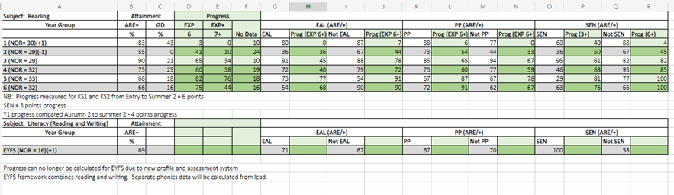
- Percentage of children passing SAT’s for Year 2 = 55% and Year 6 = 66%.
- Best Results seen in Year 1 and Year 3 respectively and best progress seen in Year 5, the same as the spring term.
- The amount of children working at GD has increased in years 1, 4, 5 and 6 since Spring 2.
- For EAL pupils compared within non-EAL, there are no significant difference in attainment in Years 1, 3 and 4. Non-EAL performed better than EAL in Years 2 and 6. EAL outperformed Non- EAL in year 5.
- Non-EAL made better progress than EAL in all year groups.
- For PP pupils compared within non-PP, there are no significant difference in attainment in Year 4 and 5. PP performed better that Non-PP children in 1, 2 and 6. Whereas Non-PP performed better in year 3.
- PP made better progress in all year groups except Year 3 where it was the same.
- Greater attainment in year groups 1, 2, 4, 5 and 6 seen for non-SEND pupils. Whereas SEN outperformed in years 3 and EYFS.
- Progress is better in Year 1, and 2 for SEND than non-SEND (Progress for SEN being +3 and progress for Non-SEND being +6)
- Compared to Autumn data, attainment has increased in all classes.
- Attainment of EAL pupils has increased in years EYFS, 1, 2, 4, 5 and 6 with very little change in year 3. The attainment of Non-EAL children has remained steady in all class apart from Year 2 and 6 were there was a significant increase.
- Attainment of PP children has increased in most years with a slight drop in year 1, 5 and 6.
- Attainment of the non-PP children has increased all classes.
- Little Wandle is having a great impact on children building those reading foundations. The number of children who have not yet passed their phonics screening is only 1 in Y3 and 1 in Y4.
- The phonics screening test had a 72% pass of the year 1 children!
- The percentage of children moving into year 1 with phase 3 phonics or above is 69% compared with 59% last year.

- 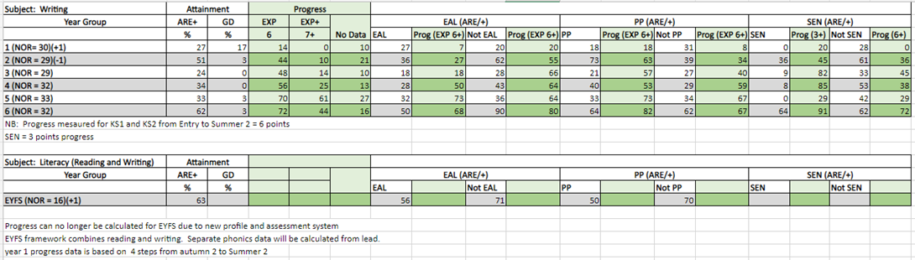
Best results seen in year 6 followed by year 2. This was similar in Autumn 2, where year 2 had the best results.
- The greatest number of greater depth writers is in year 1 (17%) followed by year 2 and 6 (3%)
- Least children at ARE are in year 3 followed by year. There is some difference form Spring term, where year 3 had the least children at ARE followed by year 4.
- Greatest progress was made in year 6 (72%: 6) followed by year 5 (70%: 6). This was the same in Autumn and Spring term.
- Least progress was made in year 1 (14%: 4) followed by year 2. This has changed since Spring term, which was year 4 followed by year 3. Progress across all year groups is greater than in Spring term.
- Non-EAL children are outperforming EAL children from year 2 - 6 with the most significant difference in year 6. This was also the case in Spring term but in autumn term, there wasn’t a significant difference between EAL and non-EAL children.
- Progress between non-EAL and EAL children varies between year groups. EAL children progress more than non-EAL in years: 5,6 and 4. Non-EAL progress more in years: 6,2 and 4 respectively.
- Attainment between PP and non-PP children is similar through school bar year 1 where it is much lower. PP children outperform non-PP significantly in year in year 2.
- Attainment for non-SEND children is better than SEND children across school. This was the same as in Autumn term.
- The best attainment for SEND children is in year 6 followed by year 2.
- The greatest progress for SEND at 3+ levels is in year 6 (91%) followed by year 4 (85%) and year 3 ( 82%)This was similar in both previous terms where it was similar year groups (year 6 and 3)
- The greatest progress for SEND at 6+ levels is in year 6 (72%) followed by year 3 (45%). In Spring term, (4+) it was year 5, followed by year 6.

- Best results seen in years 1 and 4 respectively.
- There has been an increase in all classes except year 1 of children achieving ARE+ and all classes except Year 3 and 6 in children achieving greater depth.
- EAL children in Years EYFS, 4 and 5 have performed better than non-EAL children.
- PP children performed better than non-PP in years 1, 2 and 3.
- 75% of SEND in EYFS reached GLD compared to 67% of Non-SEND.
- Greatest progress has been seen in Years 3, 4 and 6
- All EAL children across school have made better progress than Non-EAL except year 4 which is broadly inline with each other (3% difference).
- Progress for PP compared to non-PP children is better in all year groups except Year 1 where there is a difference of 8% and Year 6 which is broadly inline (difference of 3%).
- Better progress has been seen for SEND children in years 1, 2 and 4.
- Analysis from test papers shows that arithmetic is still a strength within school. Actions to be taken next academic year to improve reasoning through the use of sentence stems to develop analytical thinking and reasoning and exposure to worded problems to increase familiarity so children get used to applying their fluency within a context.

Written: September 2022
Reviewed: June 2023

