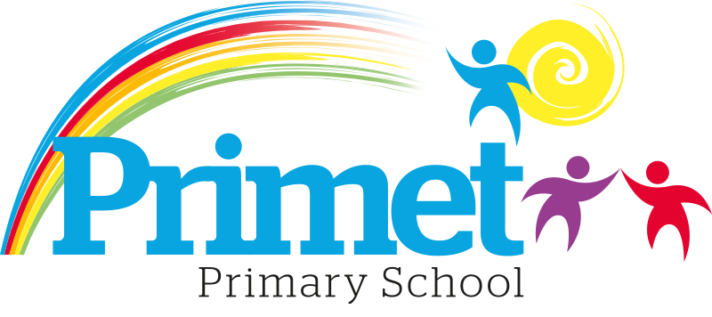
Pupil Premium Strategy statement 2023/2024

CONTEXT OF THE SCHOOL

The school is a average-sized Primary School with 188 (September 2023) pupils on roll.

Key features of the school

- 7 classes one form entry primary school.
- Socio-economic Taken from the 22/23 LSIP, Over deprivation index (A least E most deprived)
Education skills and training = E
Income = E
Employment = E
Health and Disability = E
Housing = A - because of close-proximity to public services
Crime = D
Living Environment = E
- Ethnic heritage, we have 12 different heritages at school;47% white/British, 27% Pakistani, Other white 8%, White and Asian 3%, other Asian 2% and 12% Other.
- Gender balance 44% Female 56% Male
- FSM 47% & 48% eligible for Pupil Premium funding. (EYFS PPG children to be included later once known)
- SEND 30%, 6 with EHCP 45 with SEN support. Likely to rise once EYFS included.
- CLA 0 families, 8 CAF’s
- Attendance:
Attendance including CME is 92.1% 2022/2023 -0.55% reduction.

- Mobility:
The following KS1 children were not in reception in this school at the end of that year:
Y1: 4 children: (25%)
Y2: 4 children: (13%)

The following KS2 children were not in Y2 in this school at the end of that year:
Y3: 5 children: (17%)
Y4: 5 children: (17%)
Y5: 7 children: (22%)
Y6: 13 children: (39%)

Key information

Pupil summary | 2021/2022 |  | 2022/2023 |  | 2023/2024
Number of Eligible pupils | 63 | 31%  High | 65 | 33.2%High | 81 | 48% High
Number of Eligible pupils | 63 | £88,355 | 65 | £90,025 | 81 | £119,312

Cohort information for 2023/2024

 | PPG Pupils | PPG Boys | PPG Girls | PPG SEND | NOR | PPG %
EYFS | 0 | 0 | 0 | 0 | 21 | 0%
Y1 | 7 | 5 | 2 | 3 | 16 | 44%
Y2 | 18 | 13 | 5 | 4 | 30 | 60%
Y3 | 11 | 6 | 5 | 2 | 29 | 38%
Y4 | 14 | 10 | 4 | 4 | 29 | 48%
Y5 | 15 | 6 | 9 | 2 | 32 | 47%
Y6 | 16 | 8 | 8 | 3 | 33 | 48%
Total | 81 | 48 | 33 | 18 | 190 | 43%  No EYFS 48%

Record of PPG Spending 2023/2024 Impact Report

Priorities for the spending for Pupil Premium children within the school is to close the learning gap for all disadvantaged children who access Pupil Premium funding. This spending has been directed towards improving attainment in Reading, Writing and Maths which links into our SIP 2023/2024.

Item/Project | Cost | Objective | Impact
1:1 tuition or small group work for pupils in Y2 reading recovery | £1,000 | To boost confidence and accelerate the progress of targeted individuals in Reading
Apprentice teacher in EYFS to support learning to improve outcomes. | £24,947 | To improve GLD to above 65%
Intervention Groups within all classes including Acquisition in English x1 HLTA, Phonics and other oral interventions  X6 TA’s L2/3 for working in the mornings. | £17,196  £73366.50 | To boost confidence of children who are not yet proficient in English.  To deepen the knowledge and understanding of targeted pupils in Maths and English.  To improve the language and communication skills of targeted pupils.  .

Access to breakfast | £100 for one week  May 2023 | To ensure Y2 and Y6 pupil premium children have breakfast  during SATs week & are all in school  on time
Y5/Y6 – Hygiene pack including – shampoo, shower  gel,  toothpaste/brush, deodorant, flannel, drawstring bag (£6 each) | £300 | To ensure that PP children have good hygiene habits. Year 5 and Year 6.
Resources to support interventions and catch up groups | £2,000 | CGP resources across the school for interventions and catch up groups including PP children.
Trophies | £400 | End of year trophies to build the self esteem of the children.
Total spent: £119,309.50 plus Contingency £2.50 = 119,312

Written: September 2023
Reviewed June 2024

