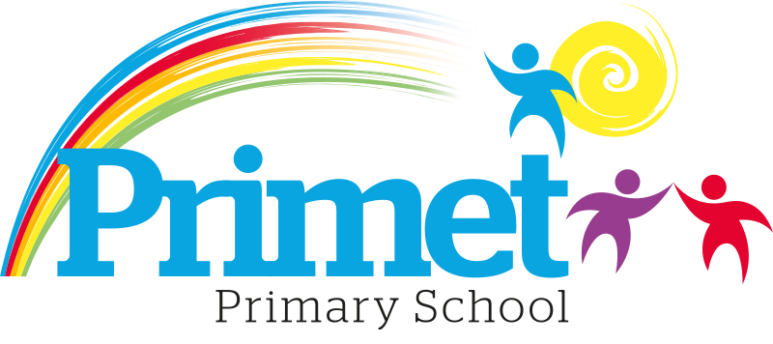
Pupil Premium Strategy statement 2022/2023

CONTEXT OF THE SCHOOL

The school is a average-sized Primary School with 195 (September 2021) pupils on roll.

Key features of the school

- 7 classes one form entry primary school.
- Socio-economic Taken from the 18/19 LSIP, Over deprivation index (A least E most deprived)
Education skills and training = E
Income = E
Employment = E
Health and Disability = E
Housing = A - because of close-proximity to public services
Crime = E
Living Environment = E
- Ethnic heritage, we have 12 different heritages at school;46% white/British, 28% Pakistani, Other white 8%, White and Asian 2%, other Asian 3%, Roma 2% and 11% Other.
- Gender balance 47.37% Female 52.63% Male
- FSM 40% & 40% eligible for Pupil Premium funding. (EYFS PPG children to be included later once known)
- SEND 19%, 3 with EHCP 34 with SEN support. Likely to rise once EYFS included.
- CLA 0 families, 8 CAF’s
- Attendance:
Attendance including CME is 92.65% 2021/2022 -2.88% reduction (September 2020 to March 2021 was 95.53%)
Attendance excluding CME is 92.65% 2021/2022, this is closing the gap with National Average.

- Mobility:
The following KS1 children were not in reception in this school at the end of that year:
Y1: 4 children: (13%)
Y2: 7 children: (27%)

The following KS2 children were not in Y2 in this school at the end of that year:
Y3: 12 children: (40%)
Y4: 12 children: (39%)
Y5: 17 children: (50%)
Y6: 20 children: (67%)

Key information

Pupil summary | 2020/2021 |  | 2021/2022 |  | 2022/2023
Number of Eligible pupils | 62 | 38% High | 63 | 31%  High | 65 | 33.2%High
Number of Eligible pupils | 62 | £76,950 | 63 | £88,355 | 65 | £90,025

Cohort information for 2022/2023

 | PPG Pupils | PPG Boys | PPG Girls | PPG SEND | NOR | PPG %
EYFS | 0 | 0 | 0 | 1 | 12 | 0%
Y1 | 17 | 12 | 5 | 3 | 30 | 57%
Y2 | 9 | 5 | 4 | 4 | 26 | 19%
Y3 | 15 | 10 | 5 | 2 | 30 | 50%
Y4 | 15 | 9 | 6 | 4 | 31 | 48%
Y5 | 13 | 6 | 7 | 2 | 33 | 39%
Y6 | 10 | 5 | 5 | 3 | 30 | 33%
Total | 79 | 47 | 32 | 19 | 192 | 38%

Record of PPG Spending 2022/2023 Impact Report

Priorities for the spending for Pupil Premium children within the school is to close the learning gap for all disadvantaged children who access Pupil Premium funding. This spending has been directed towards improving attainment in Reading, Writing and Maths which links into our SIP 2021/2022.

Item/Project | Cost | Objective | Impact
Additional L3 TA to assist in EYFS to support early reading | £11,064 | To provide focused literacy and numeracy sessions to help progress of PP children. | ELG has risen for reading 62.1% in 2022 to 68.8% in 2023  ELG has risen for Communication 62.1% in 2022 to 68.8% in 2023  The improvement is especially noticeable in boys 12/16 children from 63.2% to 83.3% in reading.  GLD has improved overall to 62.5% 2023 from 51.7% 2022.
1:1 tuition or small group work for pupils in Y2 reading recovery | £1,900 | To boost confidence and accelerate the progress of targeted individuals in Reading | The progress of pupils in year 2 was increased resulting in improved End of Key Stage SATS. Pupil premium children out performed children who are not pupil premium.  PP children attained 74% +ARE Non-PP children attained 43% +ARE. Progress has improved in Y2 for PP children EXP+6 54% Non-PP Children progress EXP+6 33%
Intervention Groups within all classes including Acquisition in English x1 HLTA, Phonics and other oral interventions  X5 TA’s L2/3 for working in the mornings. | £15,047  £55579.50 | To boost confidence of children who are not yet proficient in English.  To deepen the knowledge and understanding of targeted pupils in Maths and English.  To improve the language and communication skills of targeted pupils.  . | Early identification of communication and interaction difficulties has proved beneficial to offer intervention to ensure Speech and Language does not limit or hinder learning.  This improved Y1 phonics outcomes to 72.4% 2023 from 69.2% 2022. Closing the attainment gap to LCC outcomes of 77.5%  It has also improved attainment in Reading and Writing.  Targeted extra intervention in Early reading for Year 1 and Year 2 in 2022/2023. This has supported pupil premium children and the End of key stage scores has closed the attainment gap. Pupil Premium children do better than non-pupil premium children in end of year testing.  For the data outcomes in reading and writing and Maths
Intervention Well being Group  Training for new ELSA cover | £645 for training | To boost confidence and accelerate the progress of targeted individuals in reading and writing. This will need implementing with a member of staff to be trained.  To increase self-esteem, independence and confidence of targeted pupils. | (ELSA £3614 for 3 afternoons  full year) put into the budget once training has taken place.  Not completed. Put extra support into school with therapy with Music and Be free interventions.  These interventions offered to targeted children across the school which accelerated the progress of pupil premium children through tailored interventions and support to fill gaps in learning from starting points.

Access to breakfast | £100 for one week  May 2020 | To ensure Y2 and Y6 pupil premium children have breakfast  during SATs week & are all in school  on time | Improved outcomes for all pupils and children with pupil premium outperforming children with non-pupil premium.  All PP children attended breakfast club and were on time for their tests. Children were relaxed and calm before tests. See below for progress and results.
Y5/Y6 – Hygiene pack including – shampoo, shower  gel,  toothpaste/brush, deodorant, flannel, drawstring bag (£6 each) | £250 | To ensure that PP children have good hygiene habits. Year 5 and Year 6. | All children in Year 5 and Year 6 received a kit which was used by most children daily. Hygiene habits improved after this.  Central school resource has been created so all children can access these items if required.
Educational visits – whole school (£20 per child)  Y6 PGL  Derbyshire Y4/5 SACHS  Leavers tops for Y6 for the leaving | £ 4000  SACHS visit paid from a charity.  £250 | To give PP children across the school experiences and opportunities the same as their peers.  To ensure PP children get the opportunity to build confidence, self/esteem and resilience. | 15 children were supported with the SACHS residential in October 2022.  The short fall in costing for trips was paid for so all children could attend any visits.
Total spent: £88,835.50 plus Contingency £1,189.50 = £90,025

Written: September 2022
Reviewed June 2023

Reading (prepared by J. Novak)

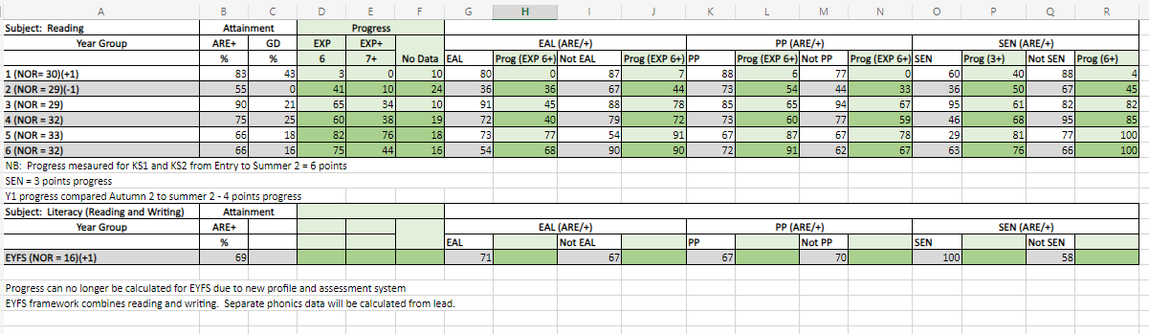
  - Percentage of children passing SAT’s for Year 2 = 55% and Year 6 = 66%.
  - Best Results seen in Year 1 and Year 3 respectively and best progress seen in Year 5, the same as the spring term.
  - The amount of children working at GD has increased in years 1, 4, 5 and 6 since Spring 2.
  - For EAL pupils compared within non-EAL, there are no significant difference in attainment in Years 1, 3 and 4. Non-EAL performed better than EAL in Years 2 and 6. EAL outperformed Non- EAL in year 5.
  - Non-EAL made better progress than EAL in all year groups.
  - For PP pupils compared within non-PP, there are no significant difference in attainment in Year 4 and 5. PP performed better that Non-PP children in 1, 2 and 6. Whereas Non-PP performed better in year 3.
  - PP made better progress in all year groups except Year 3 where it was the same.
  - Greater attainment in year groups 1, 2, 4, 5 and 6 seen for non-SEND pupils. Whereas SEN outperformed in years 3 and EYFS.
  - Progress is better in Year 1, and 2 for SEND than non-SEND (Progress for SEN being +3 and progress for Non-SEND being +6)
  - Compared to Autumn data, attainment has increased in all classes.
  - Attainment of EAL pupils has increased in years EYFS, 1, 2, 4, 5 and 6 with very little change in year 3. The attainment of Non-EAL children has remained steady in all class apart from Year 2 and 6 were there was a significant increase.
  - Attainment of PP children has increased in most years with a slight drop in year 1, 5 and 6.
  - Attainment of the non-PP children has increased all classes.
  - Little Wandle is having a great impact on children building those reading foundations. The number of children who have not yet passed their phonics screening is only 1 in Y3 and 1 in Y4.
  - The phonics screening test had a 72% pass of the year 1 children!
  - The percentage of children moving into year 1 with phase 3 phonics or above is 69% compared with 59% last year.

Writing (prepared by S. Bashir)
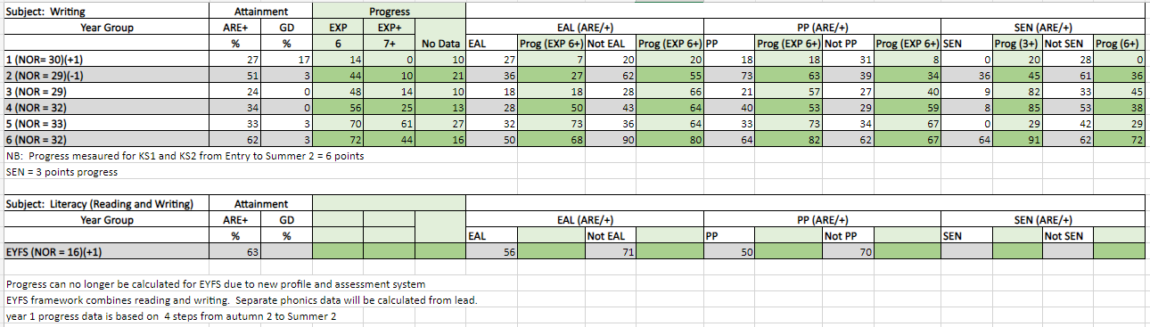
- Best results seen in year 6 followed by year 2. This was similar in Autumn 2, where year 2 had the best results.
- The greatest number of greater depth writers is in year 1 (17%) followed by year 2 and 6 (3%)
- Least children at ARE are in year 3 followed by year. There is some difference form Spring term, where year 3 had the least children at ARE followed by year 4.
- Greatest progress was made in year 6 (72%: 6) followed by year 5 (70%: 6). This was the same in Autumn and Spring term.
- Least progress was made in year 1 (14%: 4) followed by year 2. This has changed since Spring term, which was year 4 followed by year 3. Progress across all year groups is greater than in Spring term.
- Non-EAL children are outperforming EAL children from year 2 - 6 with the most significant difference in year 6. This was also the case in Spring term but in autumn term, there wasn’t a significant difference between EAL and non-EAL children.
- Progress between non-EAL and EAL children varies between year groups. EAL children progress more than non-EAL in years: 5,6 and 4. Non-EAL progress more in years: 6,2 and 4 respectively.
- Attainment between PP and non-PP children is similar through school bar year 1 where it is much lower. PP children outperform non-PP significantly in year in year 2.
- Attainment for non-SEND children is better than SEND children across school. This was the same as in Autumn term.
- The best attainment for SEND children is in year 6 followed by year 2.
- The greatest progress for SEND at 3+ levels is in year 6 (91%) followed by year 4 (85%) and year 3 ( 82%)This was similar in both previous terms where it was similar year groups (year 6 and 3)
- The greatest progress for SEND at 6+ levels is in year 6 (72%) followed by year 3 (45%). In Spring term, (4+) it was year 5, followed by year 6.

