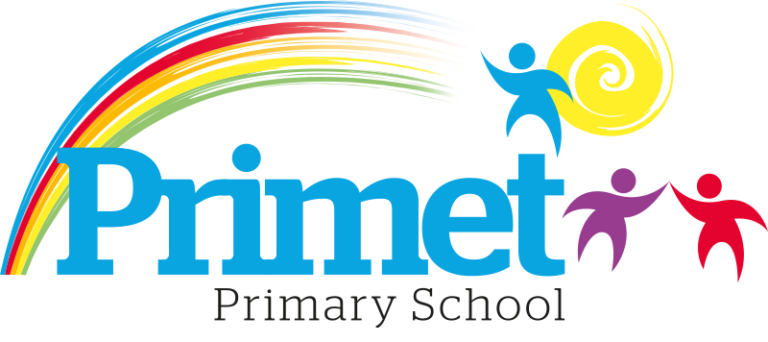
Catch up Funding Strategy statement 2022/2023

CONTEXT OF THE SCHOOL

The school is a average-sized Primary School with 195 (September 2021) pupils on roll.

Key features of the school

- 7 classes one form entry primary school.
- Socio-economic Taken from the 18/19 LSIP, Over deprivation index (A least E most deprived)
Education skills and training = E
Income = E
Employment = E
Health and Disability = E
Housing = A - because of close-proximity to public services
Crime = E
Living Environment = E
- Ethnic heritage, we have 12 different heritages at school;46% white/British, 28% Pakistani, Other white 8%, White and Asian 2%, other Asian 3%, Roma 2% and 11% Other.
- Gender balance 47.37% Female 52.63% Male
- FSM 40% & 40% eligible for Pupil Premium funding. (EYFS PPG children to be included later once known)
- SEND 19%, 3 with EHCP 34 with SEN support. Likely to rise once EYFS included.
- CLA 0 families, 8 CAF’s
- Attendance:
Attendance including CME is 92.65% 2021/2022 -2.88% reduction (September 2020 to March 2021 was 95.53%)
Attendance excluding CME is 92.65% 2021/2022, this is closing the gap with National Average.

- Mobility:
The following KS1 children were not in reception in this school at the end of that year:
Y1: 4 children: (13%)
Y2: 7 children: (27%)

The following KS2 children were not in Y2 in this school at the end of that year:
Y3: 12 children: (40%)
Y4: 12 children: (39%)
Y5: 17 children: (50%)
Y6: 20 children: (67%)

Key information

Pupil summary | 2022/2023
190 pupils | £9,860

Cohort information for 2022/2023

 | PPG Pupils | PPG Boys | PPG Girls | PPG SEND | NOR | PPG %
EYFS | 0 | 0 | 0 | 1 | 12 | 0%
Y1 | 17 | 12 | 5 | 3 | 30 | 57%
Y2 | 9 | 5 | 4 | 4 | 26 | 19%
Y3 | 15 | 10 | 5 | 2 | 30 | 50%
Y4 | 15 | 9 | 6 | 4 | 31 | 48%
Y5 | 13 | 6 | 7 | 2 | 33 | 39%
Y6 | 10 | 5 | 5 | 3 | 30 | 33%
Total | 79 | 47 | 32 | 19 | 192 | 38%

Record of Catch up Funding Spending 2022/2023 Impact Report

Priorities for the spending for Catch up funding children within the school is to close the learning gap for all children who the funding is targeted at funding. This spending has been directed towards improving attainment in Reading, Writing and EYFS which links into our SIP 2022/2023.

Item/Project | Cost | Objective | Impact
1:4 tuition or small group work for pupils in Y2, Y5 and Y6. Autumn term  Targeted intervention with the children who are just below age expected goals in core subjects for the year. | X10 session at £20= £200  X12 groups =£2,400  Resources £3600 | Spring/Summer term.  To boost confidence and accelerate the progress of targeted individuals in English and Maths to increase the number of age-related expectations at the end of Key Stage one and two. Targeted year 2 and year 6 in the spring term. These children are targeted from Autumn assessments.  CGP bought for work with interventions across all year groups.  Children will be tracked on the outcomes at the spring and EOKS assessments. | See below for impact.
1:4 tuition or small group work for pupils in Y6, Y2 and Y5. Spring Term  Targeted intervention with the children who are just below age expected goals in core subjects for the year. | X10 session at £20= £200  X12 groups =£2,400 | Spring term  To boost confidence and accelerate the progress of targeted individuals in English and Maths to increase the number of age-related expectations at the end of year 5. Targeted year 1 and year 5 in the summer term.  Children will be tracked on the outcomes at the spring and EOKS assessments. | See below for impact.
1:4 tuition or small group work for pupils in Y1 and Y5. Summer Term | X7 session at £20= £200  X8 groups =£1,120 | To be decided after the Spring assessment. | See below for impact.

Total spent: £9,520 plus Contingency £ 340= £9,860

Written: September 2022
Reviewed: June 2023

