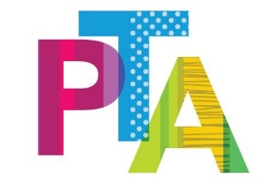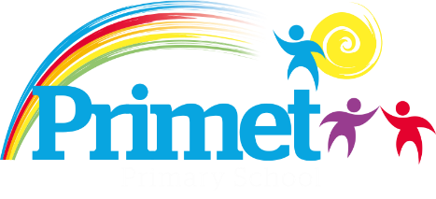
Friends of Primet Primary
Tatton Street, Colne BB8 8JE

PTA code of conduct

Our PTA code of conduct should be viewed as a means of strengthening our PTA and the school community.

Parents and carers responsible for a child attending Primet Primary are automatically a member of the PTA. In being a member, everyone has the right to be treated with respect and compassion. They also have the responsibility to be respectful of and be sensitive to the feelings of others and to work within the PTA code of conduct.

Members rights and responsibilities

- All members work as volunteers and for no personal gain. Genuine PTA expenses will be reimbursed subject to a valid receipt and approval.

- All members have the right to be heard and to communicate. They have the responsibility to listen to and to respect the ideas of others and to communicate calmly, clearly and responsibly. This responsibility includes communication via any technology including social media.

- All members have the right to expect that their person and possessions are safe and secure. They also have the responsibility to respect school property and the property of other members.

- All members must respect the privacy of school staff, children and that of other members as they carry out PTA activities.

- All members should respect and work within school policies as published on the school website.

- All members will respect the decisions of the committee even if that decision is at odds with their own wishes.

- All members are entitled to raise concerns about safety or an individual’s behaviour in relation to any PTA activity. Any concerns must be brought to the attention of either the PTA Chair, PTA committee or senior member of staff at the earliest possible opportunity.

- Committee members are expected to wear the PTA t-shirts/hoodies for event purposes only.

Behaviour that will not be tolerated:

- Disruptive behaviour which interferes or threatens to interfere with any of the school’s normal operations or activities anywhere on the school premises.
- Any inappropriate behaviour on the school premises.
- Using loud or offensive language or displaying temper.
- Threatening in any way a member of staff, visitor, fellow parent/carer or child.
- Damaging or destroying school property.
- Sending abusive or threatening emails or text/voicemail/phone messages or written communications (including social media) to anyone within the school community.
- Defamatory, offensive or derogatory comments regarding the school or any of the pupils/parents/staff/governors at the school on Facebook or other sites.
- The use of physical, verbal or written aggression towards another adult or child.

Consequences and resolution

Should a PTA member disregard the above code of conduct or if a concern regarding safety or an individual’s behaviour has been identified, the PTA Chair and or committee have the right to investigate such concerns. All concerns and investigations will be treated in confidence; however a right of reply will be given to any member involved before any action is taken.

By signing this contract, you are agreeing to uphold these standards and represent the PTA in a responsible and respectful manner. Any one in breach of these terms will be investigated and the appropriate actions will be sought.

Print name:

Sign name:

Date:

