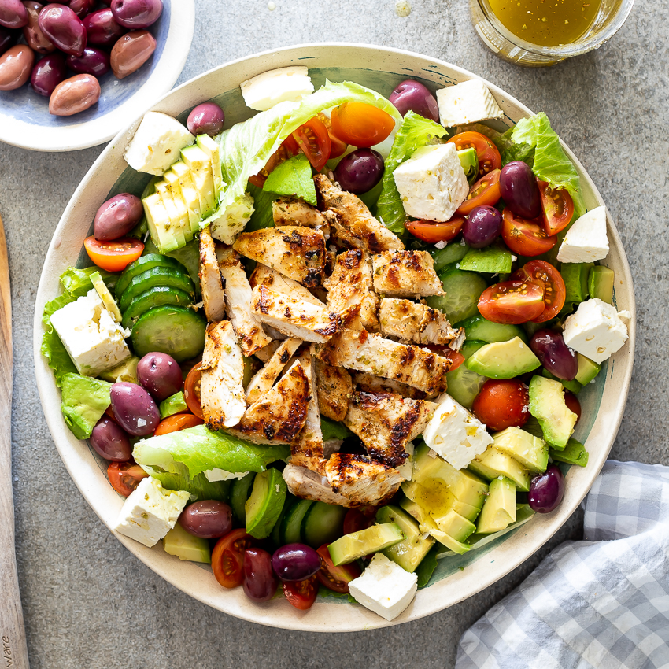

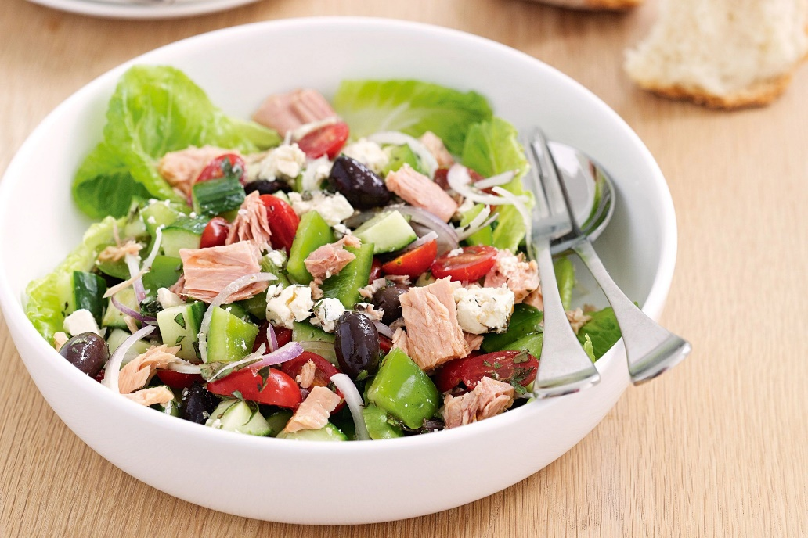

- Is the salad attractive? Why / why not?  - Have you tasted all these ingredients before? Which do you enjoy?  - How many different vegetables or fruits are in this salad?  - Do you think the colours are attractive?  - Are all the ingredients crunchy?  - Which ingredients have the strongest flavours?  - How have the ingredients been prepared?  - Where are the ingredients grown? | - Is the salad attractive? Why / why not?  - Have you tasted all these ingredients before? Which do you enjoy?  - How many different vegetables or fruits are in this salad?  - Do you think the colours are attractive?  - Are all the ingredients crunchy?  - Which ingredients have the strongest flavours?  - How have the ingredients been prepared?  - Where are the ingredients grown?

