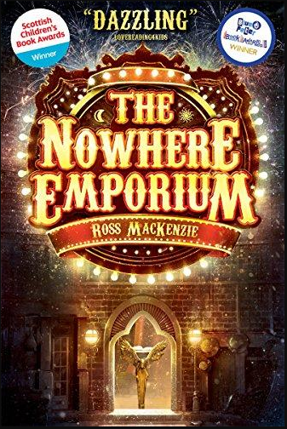
Read the prologue (p7 -10). List phrases that the author uses to create excitement and mystery.
Read the blub. What questions do you have?
What do you think the story might be about?
What genre does the book belong to?
What do think the ‘Nowhere Emporium’ is?

