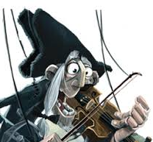
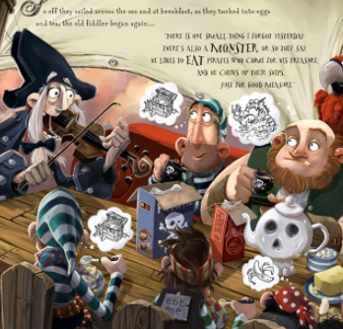
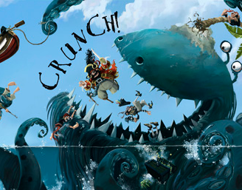
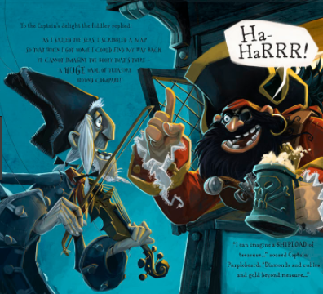
Who was actually the Fiddler?
Little did the pirates ever know but The fiddler was the sea monster all along.
The next day the pirates saw some land with the treasure. To the pirates surprise the island turned out to be the ancient sea monster. It was too late for the pirates to escape. The monster went crunch!

One day a Fiddler told Captain Purplebeard and his crew of pirates about some treasure on an island.
The pirates went off on their search to find twinkling, golden treasure. The fiddler told the crew a tale about the ancient sea monster that protects the treasure.

