

MENTAL HEALTH DIRECTORY

NAME | BRIEF DESCRIPTION | CONTACT DETAILS
  Anna Freud National Centre for Children and Families | A Children’s charity offering a range of specialist interventions and resources to support families | www.annafreud.org
  Anxiety UK | Telephone and online support for children and young people experiencing anxiety. | www.anxietyuk.org.uk  Tel: 03444 775 774
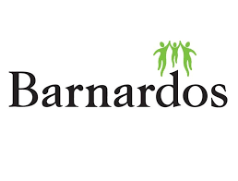  Barnardos | Our specialist workers support families through domestic abuse, mental health problems, prison sentences, asylum seeking and much more. | www.barnardos.org.uk/lancashire-young-carers.html  Email: lancashireyoungcarers@barnardos.org.uk  Tel: 01772 432020
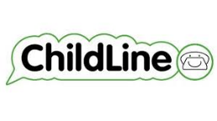  Childline | A place for children and young people to talk confidentially about something they are worried about. | www.childline.org.uk  Tel: 08001111
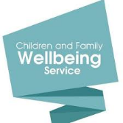  Children and Family Wellbeing Service | A range of support for families of children and young people from 0-19 years old and young people with special educational needs and/or disabilities up to 25. | Colne Neighbourhood Centre  Walton St  Colne  BB8 0EL  Tel: 01282 470830
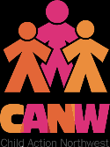  Child Action North West (CANW) | We offer support to the most vulnerable children and young people in local communities; children facing poverty, violence, abuse, neglect and family breakdown. | https://canw.org.uk/  Tel: 01254 244700  Email: info@canw.org.uk
  East Lancashire Children and Adolescent Support (ELCAS) | Offering therapeutic interventions primarily through phone and apps such as microsoft teams, whatsapp and facetime. | elht.nhs.uk/services/east-lancashire-child-and-adolescent-services  Tel: 01282 804806 between 8am and 8pm  0800 953 0110 from 8pm to 8am
  Healthy Young Minds | Variety of advice, guidance and support related to children and young people’s mental health and emotional wellbeing. | www.healthyyoungmindslsc.co.uk
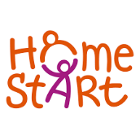  Homestart | Every Home-Start volunteer is trained to help them work alongside you to overcome the challenges you are facing. We work with you to build on your strengths and give you the support that you tell us that you need. | Tel: 01282 690536  Email: info@homestarteastlancs.org  www.homestarteastlancs.org/
  Kooth | Kooth online counselling service for 10 - 25yr olds | www.kooth.com
  Mind | A National mental health charity providing information and advice around mental health. | www.mind.org.uk
  MindED | Free educational resources on children and young people’s mental health for adults. | www.mindfull.org.uk
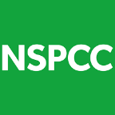  NSPCC | A UK leading charity helping to prevent child abuse. | 0808 8025544
  Talkzone | Talkzone is part of the Children and Families Wellbeing service and provides telephone helpline, text message, email enquiry and online webchat | www.lancashire.gov.uk  Tel: 0800 511 111  Text: 07786511111  Email: talkzone@lancashire.gov.uk
  The Samaritans | A confidential helpline which offers support and advice for those in emotional distress. | Tel: 116 123
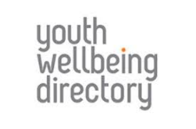  The Youth Wellbeing Directory | A free online resource which outlines local mental health services for children and young people up to 24 years old. | www.youthwellbeing.co.uk
  Young Minds | A UK wide charity committed to improving the emotional wellbeing and mental health of children and young people. | www.youngminds.org.uk  If Urgent text YM to 85258
Young Minds Parentline | Information and advice for anyone worried about a child or young person under 25 years old. | Tel: 0808 802 5544

APPS

NAME | BRIEF DESCRIPTION | NAME | BRIEF DESCRIPTION
  Headspace | Designed to help you focus, breathe, stay calm, perform at your best, and get a better night’s rest through the life-changing skills of relaxation, meditation and mindfulness |   Mindshift | Uses strategies based on Cognitive Behavioural Therapy (CBT) to help you learn to relax and be mindful, develop more effective ways of thinking, and use active steps to take charge of your anxiety
  Calm | An app for meditation and sleep. Designed to help lower stress, lessen anxiety, and assist in a more restful sleep. | 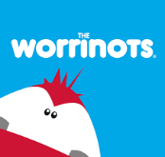  Worrinots | Provides children with a platform that they can use to communicate their worries, fears and anxieties
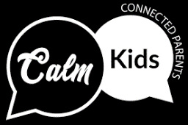  Calm kids, connected parents | Gives you resources on all kinds of parenting dilemmas at your fingertips. |   Chill Panda | An app designed to help with anxiety, managing worries and improving wellbeing for primary school-aged children
  7 cups | Free anonymous emotional support and counselling from trained active listeners. ​​​​​​ | 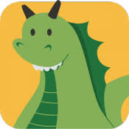  Dragon in the Attic | A game for 7 - 11 year old boys and girls about health and wellbeing choices which gives players greater awareness and confidence.
  SAM – Self-help for Anxiety Management | An app that offers a range of self-help methods for people who are serious about learning to manage their anxiety
  WellMind | Free NHS mental health and wellbeing app designed to help you with stress, anxiety and depression.

