Story Writing week 9
Use your imagination to write a story using the image below.

Kite eating tree

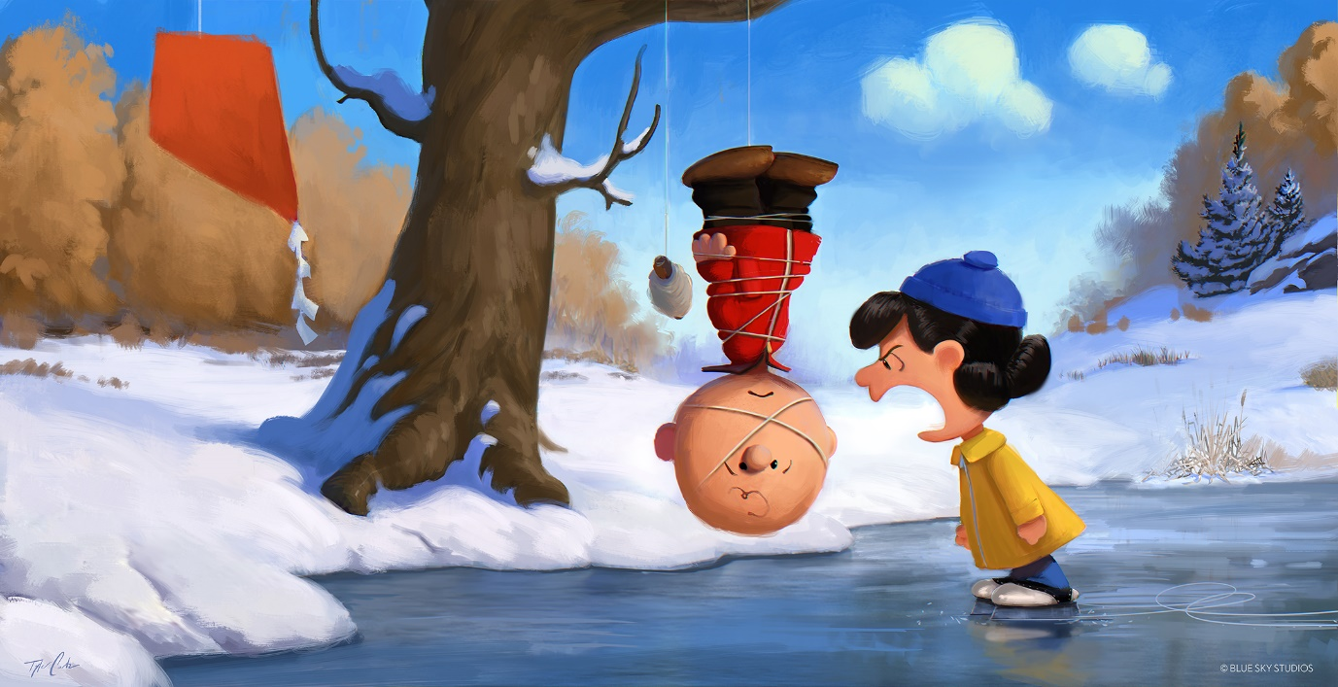
- What has happened here?
- Why is the boy hanging from the tree?
- Why is she wearing ice skates but he isn’t?
- What might she be saying to him?
- How is he going to get down?
- What happened 5 minutes before this scene? What will happen 5 minutes after?

