Story Writing week 8
Use your imagination to write a story using the image below.

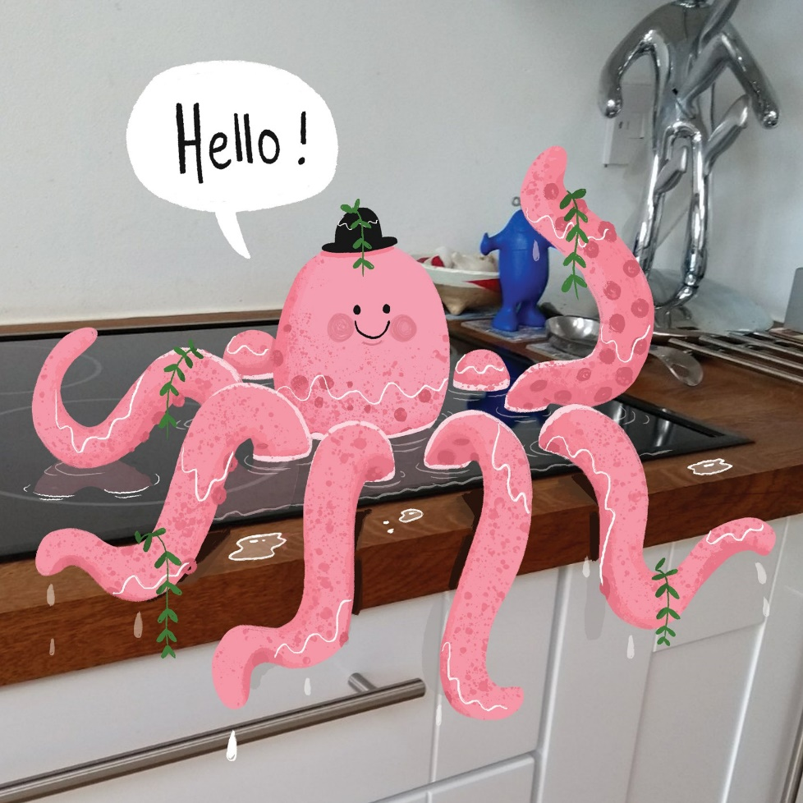
MORNING SURPRISE

Questions:
- How did the octopus get here?
- Why is it wearing a hat?
- Is it speaking your language? Do you understand what it’s saying?
- Where did the plants come from?

Write the story of how the octopus came to be here, and what happens next.

