Story Writing week 6
Use your imagination to write a story using the image below.
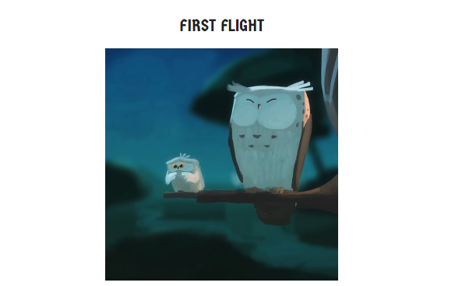

Inference
- How are the owls related?
- Which owl is about to take its first flight? How do you know?
- How does the young owl feel about flying?
- What might it be thinking? Add a thought bubble to the picture.
- Is the older owl worried?
- What advice might the older owl give to the younger one?

