Ahoy Me Hearties
'Ere be extra ideas for you to plunder!
Look at pictures of different Jolly Rogers (pirate flags) and design one of your own   | Design a pirate outfit for a pirate man or woman   | Make a treasure chest out of a shoe box (or similar size box). Decorate it and use it to store your own treasures  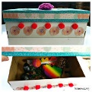  https://kidminds.org/shoebox-treasure-chest-for-kids/
Design a treasure hunt around the house – you could use everyday objects or maybe some treats. Write the clues using as much pirate language as you can.   | 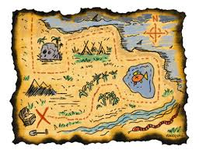  Make a treasure map.  https://www.bbc.co.uk/cbeebies/makes/swashbuckle-treasure-map  If you like a challenge, you could use co-ordinates  https://www.teachingideas.co.uk/coordinates/co-ordinates-treasure-map  Think about all the different landmarks you might have on your Treasure Island eg. Wailing Woods, Desert of Despair, Skeleton Swamp, Piranha Lagoon – see if you can make up your own
Decorate a triangular piece of cloth (ask your parents/carers for an old T-shirt or pillow case) to make your own bandanna  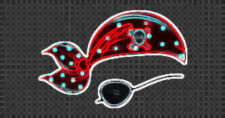 | Make a pirate picnic. You could include the following:    Buccaneer butties, cutthroat cookies and scurvy-busting fruit salad or try some of these ideas from Top Party Ideas: Pirate Food  - Canon Balls = Round cheese balls  - Polly Crackers = Cheese Ritz crackers  - Octopus = Hotdogs with octopus arms cut up  - Fish Bait = Swedish Fish Candy  - Quick Sand Dip = Hummus  - Golden Nuggets = Chicken nuggets  - Pirate Teeth = Popcorn  - Catch of the Day = Fish crackers  - Sword Kebabs = Fruit on a stick ( or any meat or veg ) | 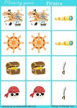  Ask your parent/carer for an old duvet cover or blanket; make a pirate den and enjoy your pirate picnic – perhaps you could invent some pirate games to play – eg pirate pairs (make two pictures each of pirate paraphernalia eg. a pair of golden doubloons; a pair of pirate hats; a pair of pirate flags; a pair of pirate ships etc. They need to be on cards/paper that is the same size. Turn them over, mix them up and put them in a grid. Take it in turns to turn over two at a time. If you get a pair, you can keep it. If not, turn them back and it's the turn of the next person. Whoever gets the most pairs is the winner!

