White Rabbit
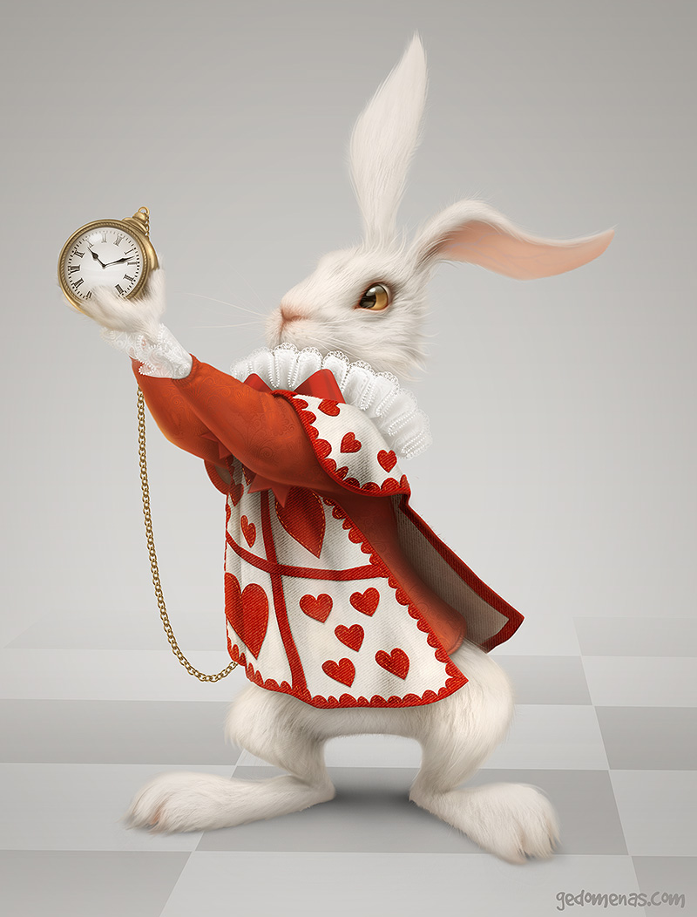

Write some sentences about this picture. Here are some tips.

- Why is the rabbit wearing these clothes?
- Why is he holding a pocket watch?
- Where is he from?
- Is he a good or bad character?
- What do you think his personality is like?
- What kind of story does he belong in? Why?

