

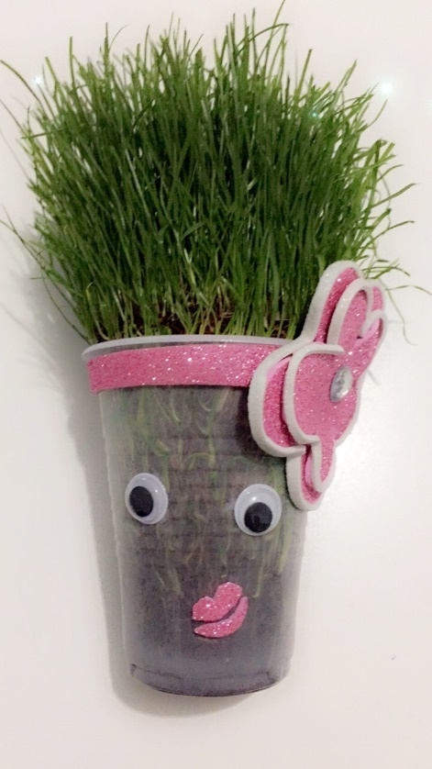
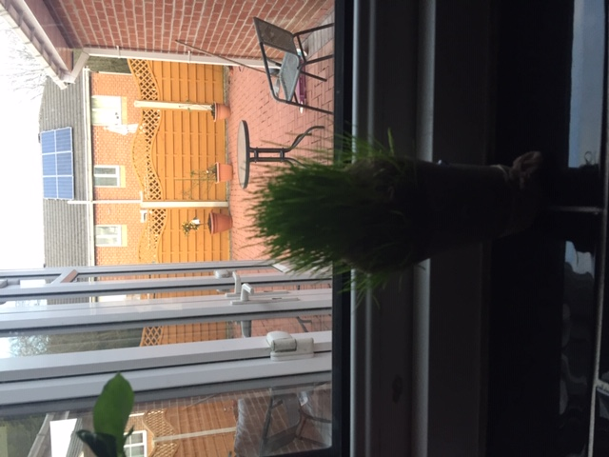
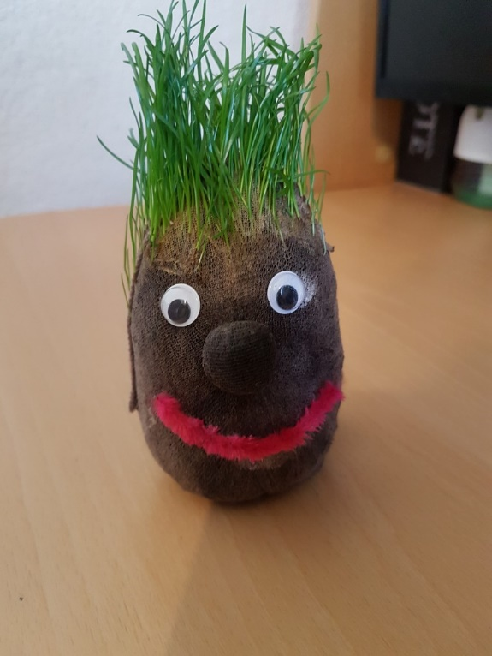
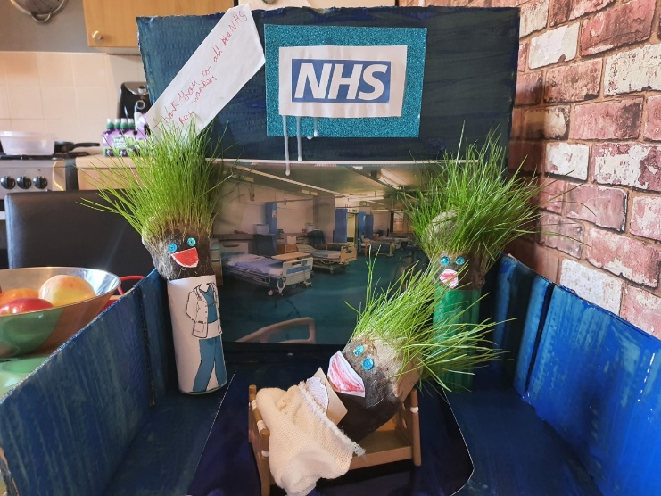
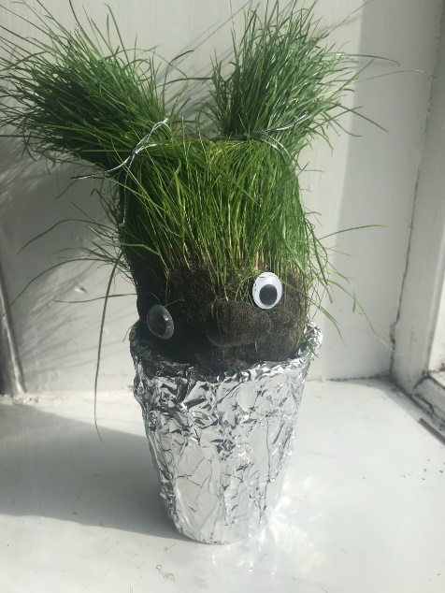
MrsRiley@primet.lancs.sch.uk
Well done to everyone who entered, these are the finalists. Great work. Winners will be announced tomorrow!
Grass head Finalists

Umme
Eliza
Luiza
Noor
Bailey
Theo
Mia

